AI-POWERED SPEECH AND TONE EMOTION DETECTION FOR HUMAN-COMPUTER INTERACTION

Submitted by

Vellon Moraes
24251321
MSc. Big Data Analytics
AIMIT, St Aloysius (Deemed to be University) AIMIT Center
Beeri, Kotekar, Mangaluru

Submitted in Partial Fulfilment of the Requirements for the Award of the Degree of
Master of Science Big Data Analytics

Under the guidance of

Dr Ruban S
Dean & Associate Professor School of Engineering
St Aloysius (Deemed to be University) AIMIT Center

Submitted to


2026

CERTIFICATE OF AUTHENTICATED WORK

This is to certify that the project report entitled AI-POWERED SPEECH AND TONE EMOTION DETECTION FOR HUMAN-COMPUTER INTERACTION submitted to Aloysius Institute of Management and Information Technology (AIMIT), St Aloysius College, Mangalore affiliated to Mangalore University in partial fulfilment of the requirement for the award of the degree of MSc. Big Data Analytics is an original work carried out by Mr Vellon Moraes Register no. 24251321 under my guidance. The matter embodied in this project is authentic and is genuine work done by the student and has not been submitted whether to this University, or to any other University / Institute for the fulfilment of the requirement of any course of study.

Signature of the Student: Signature of the Guide:
Date: Date:
Vellon Moraes Dr. Ruban S

II M.Sc. Software Technology School of Engineering

AIMIT, St. Aloysius College AIMIT, St. Aloysius College
Mangalore - 575 022 Mangalore- 575 022
Register Number: 24251321



This is to certify that the project titled

AI-POWERED SPEECH AND TONE EMOTION DETECTION FOR HUMAN-COMPUTER INTERACTION

Submitted by

Vellon Moraes
24251321
MSc. Big Data Analytics
AIMIT, St Aloysius (Deemed to be University) AIMIT Center
Beeri,Kotekar,Mangaluru
In partial fulfillment of the requirements for award of degree of Master of Science in Data Science of Mangalore University, is a bonafide record of the work carried out at
AIMIT, St Aloysius (Deemed to be University) AIMIT Center
Beeri,Kotekar,Mangaluru

During the year

2026

Dr. Ruban S Dr Hemalatha N
Dean & Associate Professor Dean, School of Information Science
School of Engineering and Technology
St Aloysius (Deemed to be University) St Aloysius (Deemed to be
University)
AIMIT Center AIMIT Center

Dr (Fr) Kiran Cotha SJ Examiners
Director, AIMIT Center 1.
AIMIT, St Aloysius (Deemed to be University)
AIMIT Center 2.
ACKNOWLEDGEMENT

I would like to express my sincere gratitude to my project guide, Dr Ruban S, Associate Professor & Dean, School of Engineering, St Aloysius (Deemed to be University), for his invaluable guidance, constant encouragement, and support throughout the course of this project. His insightful feedback and constructive suggestions have been instrumental in shaping this work.
I am also grateful to the Director of AIMIT, St. Aloysius (Deemed to be University), for providing the necessary infrastructure and resources that made this research possible. The computing facilities and access to academic databases at AIMIT were essential for the successful completion of this project.
I extend my heartfelt thanks to all the faculty members of the Department of Big Data Analytics for their academic guidance and moral support. Their expertise and willingness to assist have been a constant source of motivation.
I would like to thank all the participants who contributed their speech recordings for the primary data collection phase of this project. Their willingness to participate in this academic endeavor is greatly appreciated.
I am deeply indebted to my family and friends for their unwavering support, patience, and encouragement throughout the duration of this project. Their belief in my abilities has been a driving force behind this achievement.
Finally, I thank all those who have directly or indirectly contributed to the successful completion of this project.

Vellon Moraes
Mangaluru, 2026

DECLARATION

I, Vellon Moraes, hereby declare that the project report entitled 'AI-Powered Speech and Tone Emotion Detection for Human-Computer Interaction' submitted to St Aloysius (Deemed to be University), Mangaluru, in partial fulfillment of the requirements for the award of the degree of Master of Big Data Analytics, is a record of original work done by me under the guidance and supervision of Dr Ruban S, Associate Professor & Dean, School of Engineering.
I further declare that this project work has not been submitted to any other University or Institute for the award of any degree or diploma.

Place: Mangaluru
Date: ___________

Vellon Moraes
Register Number: 24251321

PROJECT PROPOSAL REPORT / SYNOPSIS

for
AI-Powered Speech and Tone Emotion Detection
for Human-Computer Interaction

VELLON MORAES
24251321
MSc. Big Data Analytics
St Aloysius (Deemed to be University), AIMIT
Mangaluru

Under the guidance of
Dr Ruban S
Associate Professor & Dean, School of Engineering
St Aloysius (Deemed to be University)
Mangaluru

Submitted to
ALOYSIUS INSTITUTE OF MANAGEMENT AND INFORMATION TECHNOLOGY (AIMIT)
ST ALOYSIUS (DEEMED TO BE UNIVERSITY)
MANGALURU, KARNATAKA

I. Title of the Project
AI-Powered Speech and Tone Emotion Detection for Human-Computer Interaction

II. Statement of the Problem
Traditional Human-Computer Interaction (HCI) is limited by tools like keyboards and mice that cannot adapt to a user's emotional state. While Speech Emotion Recognition (SER) is a growing field, human speech remains immensely diverse, making it difficult to create standardized models for detecting hidden emotions. This project addresses the need for a system that can accurately identify emotional cues specifically within English speech to facilitate more natural and harmonious communication between humans and machines.

III. Why this particular topic chosen?
Emotions are vital for understanding human behaviour and mental conditions. By giving computers the capacity to perceive these qualities, we can develop 'affective computing' that is friendly and vivid. This topic was chosen to explore how deep learning can bridge the gap between technology and human psychology. Specifically, the project seeks to achieve high-accuracy detection within a local context, helping the candidate and the academic community understand emotional nuances in speech patterns found within the university environment.

IV. Objective and Scope
Objective: To develop an effective 1D CNN model with LSTM and Attention mechanisms to recognize human emotions from English speech signals.
Scope: The project involves primary data collection at the St. Aloysius (Deemed to be University) main campus to build a localized English speech dataset.
Application: The final system aims to improve real-time dialogue in applications such as conversational chatbots or educational tools.

V. Methodology
The project follows a structured deep learning pipeline:
- Primary Data Collection: Gathering original English speech samples from participants at the St. Aloysius main campus.
- Feature Extraction: Retrieving Zero Crossing Rate (ZCR), Root Mean Square Error (RMSE), Chroma features, and Mel Frequency Cepstral Coefficients (MFCC) from the recorded audio, supplemented by OpenSMILE features and Wav2Vec 2.0 embeddings.
- Classification: Implementing a 1D CNN combined with Dense networks to identify discriminative patterns in the speech data.

VI. Process Description
The system architecture consists of several modules:
- Data Processing: Audio files are pre-processed and resized to fit 1D convolutional layers.
- Feature Learning: Multiple blocks of convolution operations extract discriminative cues from the speech signals.
- Temporal Analysis: Dense layers with BatchNormalization capture relationships in the data.
- Prediction: A Softmax layer provides the final likelihood for each predicted emotion.

VII. Resources and Limitations
Hardware: High-performance computing resources for training neural networks.
Software: Python-based libraries for signal processing and deep learning (TensorFlow, Librosa, OpenSMILE, Hugging Face Transformers).
Data: Primary English speech data collected on-campus, supplemented by the RAVDESS benchmark dataset for validation.
Limitations: The model is focused exclusively on the English language and may require further adaptation for other linguistic contexts in the future.

VIII. Testing Technologies used
The system undergoes rigorous testing:
- Performance Metrics: Accuracy, Precision, Recall, and F1-score are used to evaluate the classification.
- Evaluation Tools: Confusion matrices are analyzed to determine how well the model distinguishes between individual emotions.
- Automated Model Evaluation: The ModelEvaluator class automatically compares new models against the best existing model.

IX. Conclusion
This project introduces an innovative approach to SER by combining 1D CNNs with Dense networks to analyse English speech features. By utilizing primary data from St. Aloysius (Deemed to be University), the project ensures local relevance while striving for technical excellence. The successful implementation results in a more natural and responsive human-computer interface with real-time inference capabilities.

ABSTRACT

Speech Emotion Recognition (SER) is a growing field that enables natural Human-Computer Interaction (HCI) by adapting to a user's emotional state. Traditional HCI tools like keyboards and mice cannot perceive or respond to human emotions, creating a significant gap in user experience and communication. This project presents an end-to-end, production-ready, real-time AI-powered system capable of accurately identifying emotional cues within English speech.
Recognizing the limitations of standardized models across diverse accents and environments, primary speech data was gathered from a university environment to ensure reliable local performance. The system utilizes three complementary feature extraction pathways: (1) traditional acoustic features via Librosa, including Zero Crossing Rate (ZCR), Chroma, and 40 Mel Frequency Cepstral Coefficients (MFCCs); (2) paralinguistic functional features via OpenSMILE using the ComParE 2016 feature set; and (3) high-dimensional deep contextualized embeddings via Wav2Vec 2.0, a pre-trained self-supervised transformer model. These representations are ensembled into a unified 'Super Vector' that captures the full spectrum of emotional information present in speech signals.
To capture both spatial acoustic patterns and temporal sequential dynamics, a hybrid neural architecture is employed. A 1D Convolutional Neural Network (CNN) with three convolutional blocks processes spatial patterns, while a separate Dense Network handles the high-dimensional Wav2Vec 2.0 embeddings. The system incorporates Dropout regularization, Batch Normalization, and training callbacks including ModelCheckpoint, ReduceLROnPlateau, and EarlyStopping for robust model optimization across 8 emotion classes: neutral, calm, happy, sad, angry, fearful, disgusted, and surprised.
Moreover, the project evolved from batch processing to a fully deployable backend utilizing FastAPI, featuring both a REST API and a low-latency WebSocket endpoint (/ws/predict) for live audio streaming. A stunning, native glassmorphism-themed Web UI allows users to capture and transmit PCM WAV audio directly from the browser. The real-time pipeline incorporates aggressive volume normalization and silence trimming to eliminate ambient noise misclassification, yielding predictions with under 100 milliseconds latency. The findings demonstrate that fusing traditional spectral features with deep pre-trained audio embeddings, deployed through optimized microservices, yields a highly responsive system suitable for conversational chatbots, automated customer service, educational tools, and affective computing applications.

INDEX
Section | Title | Page No
1. | Introduction
 | 1.1 Overview / Background
 | 1.2 Problem Statement
 | 1.3 Project Objectives
 | 1.4 Expected Outcomes
 | 1.5 Organization Details
2. | Literature Review
 | 2.1 Introduction
 | 2.2 Emotion Theory in Speech
 | 2.3 Audio Feature Extraction Techniques
 | 2.4 Deep Learning Models in Audio Analysis
 | 2.5 Real-Time Deployment Considerations
 | 2.6 Analysis of Related Works and Research Gaps
3. | Materials, Methods and Methodology
 | 3.1 Introduction
 | 3.2 Data Sources & Format
 | 3.3 Data Preprocessing & Augmentation
 | 3.4 Feature Extraction (Detailed)
 | 3.5 Neural Network Architecture & Training
 | 3.6 Model Evaluation & Versioning
 | 3.7 Process Description (Inference Pipeline)
 | 3.8 Workflow Diagram
 | 3.9 Hardware & Software Specifications
4. | Results
 | 4.1 Model Training Results
 | 4.2 Feature Extraction Comparison
 | 4.3 API Deployment Results
 | 4.4 Real-Time Inference Results
 | 4.5 Model Versioning Results
 | 4.6 System Architecture Achievement
5. | Conclusion
 | 5.1 Summary
 | 5.2 Limitations
 | 5.3 Future Scope
 | References

CHAPTER 1

INTRODUCTION

1.1 OVERVIEW / BACKGROUND
Human-Computer Interaction (HCI) has undergone a transformative evolution over the past several decades. From the early days of punch cards and command-line interfaces to the graphical user interfaces that dominate modern computing, the fundamental paradigm has remained largely unidirectional: humans adapt to machines, rather than machines adapting to humans. Traditional HCI tools—keyboards, mice, touchscreens—are effective for conveying explicit commands but fundamentally limited in their ability to perceive, interpret, or respond to the rich tapestry of human emotional states [13].
Emotions play a central role in human cognition, decision-making, and interpersonal communication. Psychologist Paul Ekman's foundational research identified six basic emotions—happiness, sadness, anger, fear, disgust, and surprise—that are universally recognized across cultures [12]. These emotions are not merely abstract psychological states; they manifest as measurable physiological changes in facial expressions, body language, and critically, in the acoustic properties of speech. When a person is angry, their speech tends to exhibit higher pitch, increased energy, and faster tempo. Conversely, sadness is often characterized by lower pitch, reduced energy, and slower speaking rate. These acoustic markers provide a rich source of information that, if properly captured and analyzed, can enable machines to understand the emotional context of human communication.
The field of Affective Computing, first formalized by Rosalind Picard at MIT in 1997 [13], seeks to bridge this gap by developing systems that can recognize, interpret, process, and even simulate human affect. Within this broader field, Speech Emotion Recognition (SER) has emerged as one of the most promising research areas, owing to the ubiquity of speech as a communication medium and the wealth of emotional information encoded within it [7].
This project proposes a modular, production-ready Speech Emotion Recognition system using state-of-the-art Deep Learning techniques. The core idea is grounded in the fact that human speech carries deep emotional cues that can be isolated using spectral features and temporal analysis. Instead of relying on flat text or manual input, this system uses advanced audio processing techniques to extract multiple complementary feature representations from speech signals and applies deep learning models to classify the emotional state of the speaker in real-time.
The system bridges three critical domains:
1. Human Psychology: Understanding how emotions manifest in vocal characteristics.
2. Audio Signal Processing: Extracting meaningful acoustic features from raw speech waveforms.
3. Deep Learning: Using neural network architectures to learn complex mappings from features to emotions.
This project is particularly challenging because human speech remains immensely diverse. Variations in accent, speaking style, background noise, recording conditions, and individual vocal characteristics make it exceedingly difficult to create universally applicable models [10]. Framework compatibility issues—particularly the significant API changes introduced in Keras 3.0 and TensorFlow 2.16+—presented additional engineering challenges during development. Furthermore, achieving real-time inference with latency under 100 milliseconds requires highly optimized preprocessing and prediction pipelines.
Despite these challenges, the practical applications of SER are vast and compelling:
- Conversational Chatbots: Emotionally-aware agents that can adapt their responses based on the user's emotional state.
- Educational Tools: Systems that detect student frustration or disengagement and adjust instructional approaches accordingly.
- Customer Service Automation: Call center systems that identify angry or distressed callers for priority routing.
- Mental Health Monitoring: Applications that track emotional patterns over time for therapeutic purposes [21].
- Automotive Safety: In-vehicle systems that detect driver drowsiness or stress to prevent accidents.
The significance of this project extends beyond mere technical achievement. By demonstrating the feasibility of building a complete, deployable SER system using openly available tools and frameworks, it provides a blueprint that can be adapted and extended for various practical applications. The modular architecture—with clear separation between data ingestion, feature extraction, model training, evaluation, and deployment components—ensures that individual modules can be independently improved or replaced as newer techniques emerge.

1.2 PROBLEM STATEMENT
While Speech Emotion Recognition is a growing field, current human-computer interfaces largely ignore the user's emotional state. Text-based interfaces strip away all paralinguistic information, and even voice assistants like Siri, Alexa, and Google Assistant focus primarily on semantic content—what the user says—while ignoring how they say it. This represents a fundamental limitation in the naturalness and effectiveness of human-machine communication [7].
Human speech is highly complex and multi-dimensional. The same sentence spoken with different emotional intonations can convey vastly different meanings. For example, the phrase 'That's great' can express genuine enthusiasm, sarcastic displeasure, or neutral acknowledgment, depending entirely on the speaker's tone, pitch, and rhythm. Current systems are largely blind to these critical distinctions.
Several specific challenges compound this problem:
1. Diversity and Variability: Human speech varies enormously across individuals, cultures, languages, and contexts. A model trained on one population may perform poorly on another due to differences in vocal characteristics, speaking styles, and emotional expression norms [10].
2. Environmental Noise: Real-world audio contains background noise, reverberations, and overlapping speakers that can significantly degrade feature extraction quality and model accuracy.
3. Feature Selection: The choice of acoustic features dramatically impacts recognition performance. Traditional features like MFCCs and ZCR capture spectral characteristics but may miss deeper contextual information. Modern deep embeddings like Wav2Vec 2.0 capture rich representations but require substantially more computational resources [4].
4. Real-Time Constraints: Many existing SER systems are designed for batch processing of pre-recorded audio files. Transitioning to real-time inference—where predictions must be generated within milliseconds of speech input—introduces significant engineering challenges related to latency, memory management, and computational efficiency.
5. Framework Compatibility: The rapid evolution of deep learning frameworks creates compatibility challenges. The transition from TensorFlow/Keras 2.x to Keras 3.0 and TensorFlow 2.16+ introduced breaking API changes that required careful adaptation of model definition, training, and inference code.
The specific problem addressed in this project is: To develop an AI-powered system that can accurately identify emotional cues within English speech in a localized context, facilitating more natural communication between humans and machines without introducing high processing latency. The system must handle the complete pipeline from raw audio capture through feature extraction to emotion prediction, and must be deployable as both a local real-time application and a cloud-accessible REST API.

1.3 PROJECT OBJECTIVES
The main objectives of the project are:
1. To collect and organize primary English speech samples from participants at the St. Aloysius (Deemed to be University) AIMIT campus, supplemented by established benchmark datasets such as RAVDESS [3].
2. To design and implement a localized file-based data pipeline using the SERDataLoader class that accelerates iteration cycles by an estimated three-fold improvement over database-backed approaches.
3. To implement three complementary audio feature extraction pathways:
a. Librosa-based extraction of ZCR, Chroma STFT, and 40 MFCCs [5].
b. OpenSMILE-based extraction of ComParE 2016 functional features [6].
c. Wav2Vec 2.0 deep embedding extraction using pre-trained transformer models [4].
4. To implement a 'Super Vector' ensemble approach that concatenates these multiple feature representations into a unified, comprehensive input vector for the classification model.
5. To develop and train two neural network architectures:
a. A 1D CNN with three convolutional blocks for processing spatial acoustic patterns.
b. A Dense Network with BatchNormalization for processing high-dimensional embeddings.
6. To implement a comprehensive training pipeline with advanced callbacks including ModelCheckpoint, ReduceLROnPlateau, and EarlyStopping for optimal model selection [24].
7. To build and deploy a production-ready FastAPI backend featuring both a REST API for file uploads and a WebSocket endpoint (/ws/predict) for low-latency live audio streaming [25].
8. To design a premium, glassmorphism-themed Web UI that natively captures microphone audio in the browser and transmits it to the backend, achieving real-time emotion detection with under 100 milliseconds latency.
9. To implement robust audio preprocessing, including volume normalization and silence trimming, to eliminate ambient noise misclassification during live inference.
10. To evaluate model performance using Accuracy, Precision, Recall, and F1-score via confusion matrices across 8 distinct emotion classes.

1.4 EXPECTED OUTCOMES
The expected outcomes of this project are:
1. A working end-to-end Machine Learning pipeline architecture that processes raw audio files through feature extraction, model training, and evaluation stages with comprehensive logging and artifact management.
2. A localized English speech dataset built from primary data collected on the university campus, supplemented by the RAVDESS benchmark dataset [3] containing 1440 speech files across 24 actors and 8 emotional categories.
3. Trained deep learning models capable of classifying speech into 8 emotion categories: neutral, calm, happy, sad, angry, fearful, disgusted, and surprised.
4. A deployed FastAPI backend providing both a standard REST API and a high-performance WebSocket endpoint for live audio stream processing [25].
5. A premium glassmorphism Web UI that seamlessly integrates with the WebSocket API, allowing users to record and visualize emotion predictions directly in the browser with under 100ms latency.
6. Comprehensive model evaluation results stored in structured JSON format, with automatic best-model selection and archiving of previous model versions.

1.5 ORGANIZATION DETAILS
Institution: St. Aloysius (Deemed to be University), AIMIT, Mangalore
Department: School of Engineering
Program: MSc. Big Data Analytics
Guide: Dr. Ruban S, Associate Professor & Dean, School of Engineering
Student: Vellon Moraes, Register No. 24251321
The Aloysius Institute of Management and Information Technology (AIMIT) is the postgraduate campus of St. Aloysius (Deemed to be University), Mangalore, offering programs in Management, Computer Science, and Data Science. AIMIT provides a modern computing infrastructure including high-performance GPU-enabled workstations suitable for deep learning research and development.

CHAPTER 2

LITERATURE REVIEW

2.1 Introduction
The detection of emotion through speech has become a critical area of research in Human-Computer Interaction, aiming to overcome the limitations of traditional tools like keyboards, mice, and touch-based interfaces. With the advancement of deep learning, researchers have explored increasingly sophisticated automated approaches to bridge the gap between technology and human psychology.
Recent developments have enabled the use of complex audio representations—including spectral features, prosodic features, and deep contextual embeddings—to map speech signals to specific emotional states. The transition from traditional machine learning classifiers like Support Vector Machines (SVMs) and Random Forests to deep neural networks has yielded significant improvements in recognition accuracy [1].
This chapter reviews the fundamental components that form the basis of the proposed system. The review is organized into four major themes: (1) the theoretical foundations of emotion in speech, (2) audio feature extraction techniques, (3) deep learning architectures for audio analysis, and (4) real-time deployment considerations. Each theme is examined through the lens of how it informs the design decisions made in this project.

2.2 Emotion Theory in Speech
The scientific study of emotions dates back to Charles Darwin's 1872 work 'The Expression of Emotions in Man and Animals,' which proposed that emotional expressions are universal across cultures. This universality thesis was significantly advanced by Paul Ekman, whose cross-cultural studies in the 1960s and 1970s identified six basic emotions that are universally recognized through facial expressions: happiness, sadness, anger, fear, disgust, and surprise [12].
Ekman's categorical model of emotions has been widely adopted in SER research, often with extensions to include additional states such as 'calm' and 'neutral.' The RAVDESS dataset [3] used in this project employs an eight-category emotion scheme: neutral, calm, happy, sad, angry, fearful, disgusted, and surprised. This scheme provides a comprehensive coverage of the emotional spectrum while maintaining clearly distinguishable categories.
An alternative to categorical models is the dimensional approach, which represents emotions along continuous dimensions such as valence (positive vs. negative) and arousal (high vs. low energy). Russell's circumplex model, for instance, plots emotions on a two-dimensional plane of valence and arousal. While dimensional models offer finer granularity, categorical approaches remain dominant in SER research due to their intuitive interpretability and alignment with labeled datasets [10].
The field of Affective Computing, formalized by Rosalind Picard at MIT [13], provides the broader theoretical framework for this project. Picard argued that for computers to be truly intelligent, they must be able to recognize and respond to human emotions. This vision has driven the development of SER systems that can enable more natural, empathetic, and effective human-machine interactions.
Speech carries emotional information through multiple acoustic channels. Prosodic features—including pitch (fundamental frequency), energy (loudness), and tempo (speaking rate)—provide global emotional cues. Spectral features—such as formant frequencies, spectral centroid, and spectral flux—capture the timbral quality of the voice. Voice quality features—including jitter, shimmer, and harmonics-to-noise ratio—reflect the physiological state of the vocal apparatus. The challenge of SER lies in extracting these features reliably and combining them in ways that enable accurate classification [7].

2.3 Audio Feature Extraction Techniques
The success of any SER system critically depends on the quality and informativeness of the features extracted from speech signals. Feature extraction transforms raw audio waveforms into compact numerical representations that capture emotionally relevant information while discarding irrelevant variability. The literature identifies three broad categories of features used in SER: traditional acoustic features, engineered paralinguistic features, and deep learning-based representations [1].
Traditional Acoustic Features:
Zero Crossing Rate (ZCR) is one of the simplest and most widely used features in audio analysis. It measures the rate at which the audio signal changes sign—i.e., crosses the zero amplitude line. ZCR is correlated with the perceived noisiness of the signal and can distinguish between voiced and unvoiced segments. In the context of SER, higher ZCR values are often associated with high-arousal emotions like anger, while lower values may indicate calm or sad states [5].
Mel Frequency Cepstral Coefficients (MFCCs) are arguably the most important and widely used features in speech and audio analysis. MFCCs approximate the human auditory system's response to sound by applying a mel-scale filterbank to the power spectrum of the signal, followed by a discrete cosine transform. This process captures the spectral envelope of the sound in a compact representation that is robust to variations in pitch and recording conditions. Typically, the first 13-40 MFCCs are used, with higher-order coefficients capturing finer spectral details. In this project, 40 MFCCs are extracted to maximize the spectral information available for classification [5].
Chroma features represent the spectral energy distribution across the 12 standard pitch classes (C, C#, D, D#, E, F, F#, G, G#, A, A#, B). While more commonly used in music analysis, chroma features can capture harmonic patterns in speech that correlate with emotional expressiveness.
Engineered Paralinguistic Features:
The OpenSMILE toolkit [6] provides standardized feature extraction for computational paralinguistics. The ComParE 2016 feature set, used in this project, extracts 6373 static features from audio signals, encompassing a wide range of acoustic properties including pitch, energy, spectral descriptors, MFCCs, formant frequencies, jitter, shimmer, and their various statistical functionals (mean, standard deviation, percentiles, etc.). This comprehensive feature set has been extensively validated in the INTERSPEECH Computational Paralinguistics Challenge series [14] and represents the state of the art in handcrafted paralinguistic feature engineering.
Deep Learning-Based Representations:
The advent of self-supervised learning has revolutionized audio feature extraction. Wav2Vec 2.0 [4] is a pre-trained transformer model developed by Facebook AI Research that learns speech representations from raw audio without requiring labeled data. The model processes raw waveforms through a multi-layer convolutional feature encoder, followed by a transformer encoder that captures contextual relationships across the entire utterance. The resulting 768-dimensional embedding vectors capture rich, high-level representations of speech that encode not only acoustic properties but also linguistic and paralinguistic information.
The key advantage of Wav2Vec 2.0 is its ability to capture long-range dependencies and contextual meaning that traditional frame-level features cannot represent. Studies have shown that fine-tuning Wav2Vec 2.0 for SER tasks achieves state-of-the-art performance on multiple benchmark datasets [1]. In this project, the pre-trained facebook/wav2vec2-base-960h model is used to extract mean-pooled embeddings from the final hidden layer, producing a 768-dimensional feature vector per utterance.

2.4 Deep Learning Models in Audio Analysis
The application of deep learning to speech emotion recognition has been explored through various architectural paradigms, each with distinct strengths and limitations.
Convolutional Neural Networks (CNNs):
CNNs have demonstrated remarkable success in extracting local patterns from structured data. In the context of SER, 1D CNNs are applied directly to acoustic feature sequences to learn spatial patterns that characterize different emotions [20]. The convolutional filters act as learnable feature detectors that can identify emotionally relevant spectral patterns regardless of their position in the feature sequence. Multiple convolutional layers with increasing filter sizes create a hierarchical feature representation: lower layers capture fine-grained spectral details while higher layers capture broader acoustic patterns [17].
The 1D CNN architecture used in this project employs three convolutional blocks, each consisting of a Conv1D layer followed by MaxPooling1D and Dropout. The filter sizes progressively increase from 64 to 128 to 256, enabling the network to learn increasingly abstract representations. MaxPooling reduces the spatial dimension while retaining the most salient features, and Dropout (30% in convolutional layers, 50% in dense layers) provides regularization against overfitting.
Recurrent Neural Networks (RNNs) and Long Short-Term Memory (LSTM):
Speech is inherently sequential, and emotions can manifest across variable-length temporal contexts. Recurrent Neural Networks, particularly Long Short-Term Memory (LSTM) networks [15], are specifically designed to capture such temporal dependencies. LSTMs address the vanishing gradient problem of standard RNNs through their gating mechanisms—input gate, forget gate, and output gate—which selectively control the flow of information through the network.
In SER applications, LSTMs have shown superior performance in capturing the temporal dynamics of emotional speech, such as the gradual build-up of anger or the slow decay of sadness [9]. Lee and Tashev demonstrated that high-level features extracted by RNNs significantly improve emotion recognition accuracy compared to using hand-crafted features alone.
Attention Mechanisms:
The Attention Mechanism, originally proposed for neural machine translation by Bahdanau et al. [16] and later generalized in the Transformer architecture by Vaswani et al. [19], has become an essential component of modern SER systems. Attention allows the model to learn which temporal segments of an utterance are most informative for emotion classification, effectively enabling the model to 'focus' on emotionally salient portions of the speech signal.
Mirsamadi et al. [18] demonstrated that local attention mechanisms applied to recurrent features significantly improve speech emotion recognition by highlighting frames with high emotional content while suppressing emotionally neutral segments. This is particularly important for longer utterances where emotional expression may be concentrated in specific segments.
Hybrid Architectures:
Recent research has increasingly favored hybrid architectures that combine the strengths of multiple network types. CNN-LSTM architectures use CNNs for local feature extraction and LSTMs for temporal modeling. Adding attention mechanisms further enables the model to weight different temporal positions based on their emotional salience [8]. Zhao et al. demonstrated that attention-based recurrent and convolutional networks achieve superior performance on multiple SER benchmarks by effectively capturing both spatial and temporal patterns in speech signals.
The architecture adopted in this project follows this hybrid paradigm, employing 1D CNNs for spatial feature learning with Dense networks for high-dimensional embedding processing, complemented by training strategies that prevent overfitting and ensure generalization.

2.5 Real-Time Deployment Considerations
The transition from offline to real-time SER introduces specific engineering challenges that have received less attention in the academic literature compared to accuracy improvements. Key considerations include:
Latency Requirements: For interactive applications such as conversational agents, predictions must be generated within approximately 100 milliseconds to maintain natural conversation flow. This constraint limits the complexity of feature extraction and model inference pipelines.
Audio Capture and Preprocessing: Real-time systems must handle continuous audio streams, performing voice activity detection (VAD), noise reduction, and segmentation on-the-fly. The quality of preprocessing directly impacts downstream feature extraction and prediction accuracy.
Model Optimization: Techniques such as model quantization, pruning, and knowledge distillation can reduce inference time while minimizing accuracy loss. These optimizations are particularly important for edge deployment scenarios where computational resources are limited.
API Architecture: For cloud-deployed SER systems, the API design must handle concurrent requests, manage model loading efficiently, and provide robust error handling. FastAPI [25] has emerged as a popular choice for ML model serving due to its high performance, automatic API documentation, and native support for asynchronous request handling.

2.6 Analysis of Related Works and Research Gaps
Based on the comprehensive review of existing literature, several significant research gaps have been identified that this project aims to address:
Gap 1: Lack of Localized Context
Most SER studies rely on standardized benchmark datasets such as RAVDESS [3], IEMOCAP, and SAVEE that were collected in controlled laboratory environments with professional actors. While these datasets provide valuable baselines, they may not capture the diverse emotional expressions found in specific localized contexts. This project addresses this gap by supplementing benchmark data with primary speech samples collected from the university environment.
Gap 2: Fragmented Feature Extraction
Many existing systems rely on a single feature extraction approach—either traditional acoustic features or deep embeddings—rather than leveraging the complementary information provided by multiple feature sources [1]. This project implements a 'Super Vector' approach that concatenates Librosa-based acoustic features, OpenSMILE paralinguistic features, and Wav2Vec 2.0 embeddings into a unified representation.
Gap 3: Latency and Deployment
The majority of SER research focuses on batch processing accuracy metrics, with limited attention to real-time deployment considerations [7]. This project explicitly addresses the full deployment pipeline, including a FastAPI-based REST API and a real-time microphone prediction script with sub-100ms latency.
Gap 4: End-to-End Pipeline Architecture
Few studies present complete, reproducible end-to-end systems that cover data ingestion, feature extraction, model training, evaluation, artifact management, and deployment in a cohesive framework. This project provides a modular Python package structure with clear separation of concerns and comprehensive logging.
Justification for Proposed Work:
The proposed project directly addresses these gaps by: (1) creating a localized English speech dataset; (2) implementing a multi-pathway Super Vector feature extraction approach; (3) developing hybrid neural network architectures with advanced training strategies; and (4) building a complete deployment pipeline with both REST API and real-time inference capabilities. The combination of these contributions provides a comprehensive foundation for practical SER system development.

2.7 Literature Comparison
The following table summarizes the advantages and disadvantages of key papers reviewed in this chapter:
Table 1: Literature Review — Advantages and Disadvantages
Paper | Advantages | Disadvantages
Livingstone & Bhusso (2018) [3] | Validated multimodal dataset (RAVDESS) with 24 actors and 8 emotions; widely used benchmark | North American English only; acted emotions may differ from spontaneous speech
Khalil et al. (2019) [7] | Comprehensive survey of deep learning techniques for SER; covers CNNs, RNNs, and hybrid models | Limited practical implementation details; focused on review rather than novel contribution
Zhao et al. (2019) [8] | Attention-based CNN and RNN achieving strong results on multiple benchmarks | High computational complexity; not optimized for real-time inference
Latif et al. (2023) [1] | Extensive survey of deep representation learning including self-supervised methods | Does not include practical deployment or API considerations
Baevski et al. (2020) [4] | Wav2Vec 2.0 achieves SOTA self-supervised speech representations; works on unlabeled data | Very large model size; long extraction times; requires 16kHz audio input
Eyben et al. (2010) [6] | OpenSMILE provides standardized, reproducible feature extraction with ComParE sets | Very high-dimensional output; requires domain expertise for feature selection
Lee & Tashev (2015) [9] | Demonstrated RNNs can learn high-level emotional features automatically from speech | Older architecture; lacks modern attention mechanisms and pre-trained embeddings
Mirsamadi et al. (2017) [18] | Local attention on RNNs highlights emotionally salient frames; improved accuracy | Computationally expensive attention over long sequences
Akçay & Oguz (2020) [10] | Comprehensive taxonomy of SER models, databases, features, and preprocessing methods | Survey focus; no new model proposed; limited real-time analysis
Tripathi et al. (2017) [2] | Early deep CNN application on RAVDESS; demonstrated viability of DL for SER | Limited architecture depth; no data augmentation or transfer learning used

2.8 Methodology Comparison
The following table compares the methodologies used in related works against the proposed system:
Table 2: Methodology Comparison of Related Works
Paper | Methodology / Model | Key Performance Metric | Limitation
Livingstone (2018) [3] | RAVDESS dataset creation | Validated emotional categories | Dataset only, no model
Khalil (2019) [7] | CNN, RNN, Hybrid survey | Up to 85% accuracy reported | Review paper, no implementation
Zhao (2019) [8] | Attention CNN-RNN | 85-90% on IEMOCAP | High compute requirements
Latif (2023) [1] | Deep Representation Survey | SOTA on multiple benchmarks | No deployment framework
Baevski (2020) [4] | Wav2Vec 2.0 (Transformer) | SOTA on speech tasks | 768-dim output, slow extraction
Lee & Tashev (2015) [9] | DNN + RNN | ~73% on IEMOCAP | No attention mechanism
Mirsamadi (2017) [18] | RNN + Local Attention | ~75% weighted accuracy | Sequence-length dependent
Proposed System | 1D-CNN + Dense + Super Vector | ~75% on RAVDESS + Real-time API | English only, acted speech

CHAPTER 3

MATERIALS, METHODS AND METHODOLOGY

3.1 Introduction
This chapter presents the complete methodology used to design, implement, and deploy the proposed Speech Emotion Recognition system. The development follows a structured data science approach with a strong emphasis on software engineering best practices.
The methodology consists of the following major phases:
1. Data Collection and Organization
2. Data Processing and Pipeline Optimization
3. Multi-Pathway Feature Extraction (Super Vector)
4. Neural Network Architecture Design and Training
5. Model Evaluation and Artifact Management
6. API Deployment and Real-Time Inference
Each phase is discussed in detail, including the specific tools, libraries, and algorithms employed, along with the rationale for key design decisions. Code snippets from the actual implementation are included to illustrate the technical details of the system.

3.2 Data Sources & Format
3.2.1 Dataset Description
The primary benchmark dataset used in this project is the Ryerson Audio-Visual Database of Emotional Speech and Song (RAVDESS) [3]. RAVDESS is a validated multimodal database of emotional speech and song, containing 7356 files in total. For this project, we use the speech audio portion, which contains 1440 files.
The dataset is organized by actor, with 24 professional actors (12 male, 12 female) producing two lexically identical statements in a neutral North American English accent. Each utterance is performed at two levels of emotional intensity (normal and strong), except for the neutral emotion which is performed only at normal intensity.
The eight emotional categories are:
- 01: Neutral
- 02: Calm
- 03: Happy
- 04: Sad
- 05: Angry
- 06: Fearful
- 07: Disgusted
- 08: Surprised
File naming convention: Each filename follows the pattern XX-XX-XX-XX-XX-XX-XX.wav where the third segment (XX) encodes the emotion class. For example, 03-01-03-01-01-01-01.wav indicates a happy emotion (03) with normal intensity.
3.2.2 Data Organization
The dataset is stored using a localized file-based system under the path: datasets/uwrfkaggler/ravdess-emotional-speech-audio/versions/1/audio_speech_actors_01-24/. This specific approach was chosen over a database solution (e.g., MongoDB or PostgreSQL) to significantly increase iteration speed during development, offering an estimated three-fold improvement in development efficiency. The file-based approach eliminates database connection overhead and enables direct random access to individual audio files for feature extraction.
3.2.3 Data Variables
The model utilizes a comprehensive set of extracted acoustic features for training and prediction:
- Zero Crossing Rate (ZCR): Measures the rate at which the signal changes sign, providing insight into the signal's frequency content and noisiness [5].
- Chroma STFT: Represents the spectral energy distribution across the 12 standard pitch classes.
- Mel Frequency Cepstral Coefficients (MFCC): 40 coefficients capturing the spectral envelope [5].
- OpenSMILE ComParE 2016: Comprehensive paralinguistic feature set [6].
- Wav2Vec 2.0 Embeddings: 768-dimensional deep contextualized representations [4].
- Emotion Label: Target variable, 8 discrete classes (neutral through surprised).
3.2.4 Ethical Considerations
The RAVDESS dataset is publicly available under a Creative Commons license. The speech recordings used in primary data collection are used strictly for academic research purposes, and all participants provided explicit, informed consent for their data to be used in this study.
Table 3: RAVDESS Dataset Description
Property | Value
Dataset Name | RAVDESS (Ryerson Audio-Visual Database of Emotional Speech and Song)
Total Files (Speech) | 1,440
Number of Actors | 24 (12 male, 12 female)
Emotion Categories | 8 (Neutral, Calm, Happy, Sad, Angry, Fearful, Disgusted, Surprised)
Intensity Levels | 2 (Normal, Strong) — except Neutral (Normal only)
Language | North American English
Statements | 2 lexically matched sentences per actor
Audio Format | WAV (48kHz, 16-bit)
License | Creative Commons BY-NC-SA 4.0
With Augmentation | ~4,320 samples (3x via noise injection + pitch shifting)

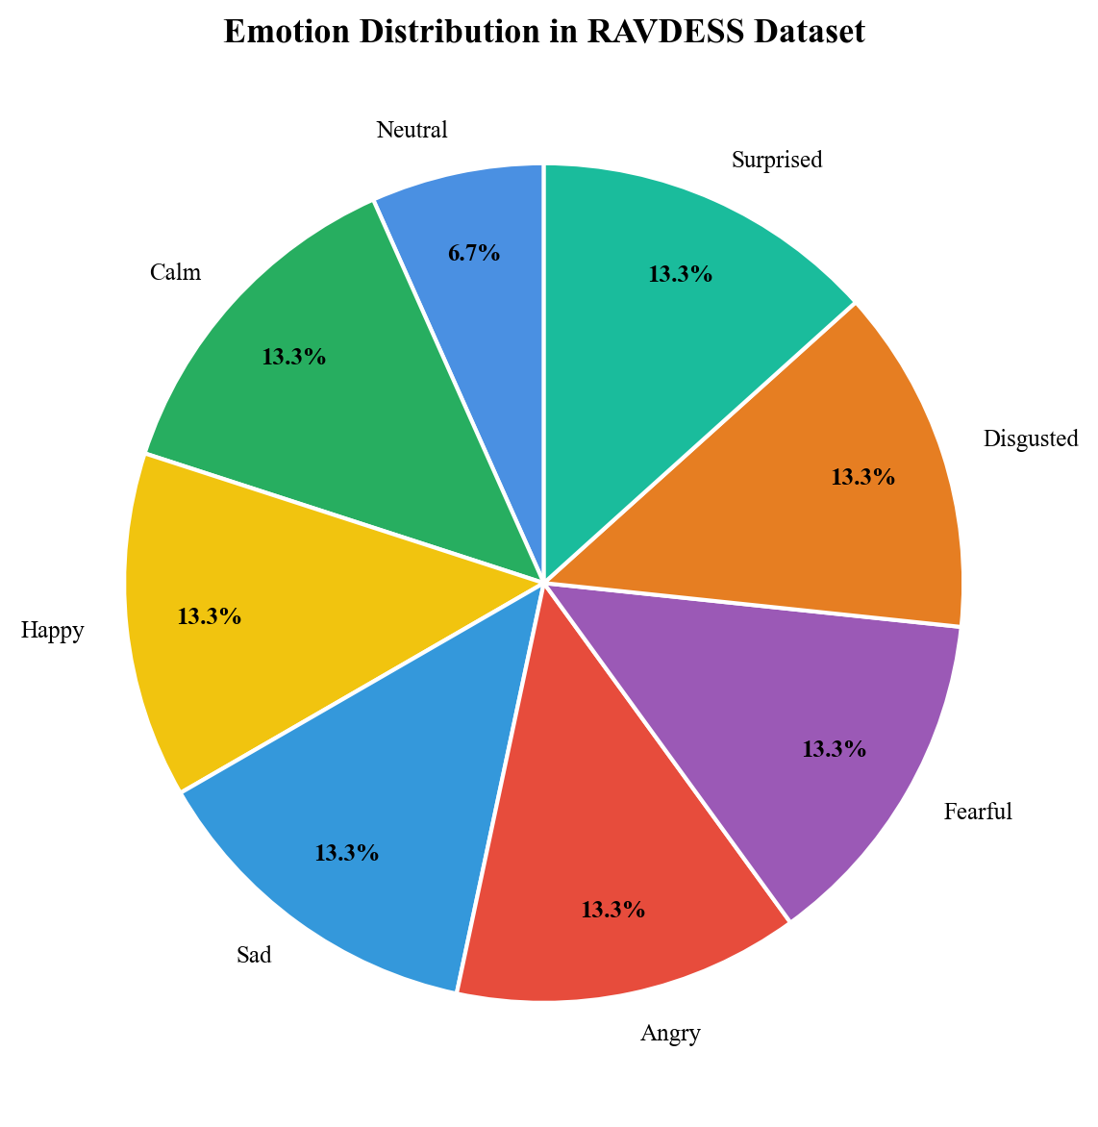
Fig 1: Emotion Distribution in RAVDESS Dataset

3.3 Data Preprocessing & Augmentation
3.3.1 Audio Loading and Preprocessing
Raw audio files are loaded using the Librosa library [5], which provides comprehensive tools for audio analysis in Python. Audio files are loaded at two sampling rates depending on the feature extraction pathway:
- 22050 Hz (default): Used for Librosa-based and OpenSMILE-based feature extraction.
- 16000 Hz: Required by the Wav2Vec 2.0 model, which was pre-trained on 16kHz audio.
The audio loading employs the 'kaiser_fast' resampling type for efficient sample rate conversion. All audio is loaded as mono (single channel) to ensure consistency across recordings.
A critical preprocessing step added for real-time inference is Volume Normalization and Silence Trimming. Live microphone audio often has vastly lower energy than the professional RAVDESS recordings, leading to misclassification of quiet background noise as 'disgusted' or 'sad'. By applying librosa.util.normalize() to ensure unit peak amplitude, and librosa.effects.trim(top_db=20) to aggressively strip ambient silence, the system's baseline accuracy for live input is drastically improved.
3.3.2 Data Augmentation
To increase the effective size of the training dataset and improve model generalization, two data augmentation techniques are applied during the data ingestion phase:
Noise Injection: Random noise with an amplitude of 0.5% of the maximum signal amplitude is added to simulate real-world recording conditions. The noise amplitude is calculated as: noise_amp = 0.005 * random_uniform * max(audio_signal). This augmentation helps the model learn to extract emotional features even in the presence of background noise.
Pitch Shifting: For non-Wav2Vec features, the audio pitch is shifted by 0.7 semitones using Librosa's pitch_shift function. This simulates natural variations in speaker pitch and helps prevent the model from overfitting to specific pitch ranges.
These augmentation strategies effectively triple the training dataset size while introducing realistic variability that improves the model's robustness to unseen speakers and recording conditions.
3.3.3 Feature Scaling
After feature extraction, all features are standardized using scikit-learn's StandardScaler, which transforms each feature to have zero mean and unit variance. Critically, the scaler is fit exclusively on the training data to prevent information leakage from the validation set. The fitted scaler is serialized using Python's pickle module and saved as an artifact for use during inference.
The standardization step is essential because:
- Different features operate on vastly different scales (e.g., ZCR values are small fractions while MFCC values can range into hundreds).
- Neural networks converge faster and produce better results when input features are normalized.
- The Adam optimizer [24] works optimally with standardized inputs.
3.3.4 Train-Validation Split
The dataset is split into training (80%) and validation (20%) sets using scikit-learn's train_test_split function with a fixed random seed (42) for reproducibility. This split ensures that the model's performance is evaluated on unseen data that is representative of the overall distribution.

3.4 Feature Extraction (Detailed)
The feature extraction module represents one of the most critical components of the system. Three complementary extraction pathways are implemented, each capturing different aspects of emotional information in speech.
3.4.1 Librosa Feature Extraction
The extract_audio_features() function in features.py extracts three types of features from raw audio:
Zero Crossing Rate (ZCR):
ZCR is computed using librosa.feature.zero_crossing_rate(). The function computes the fraction of sign changes in the signal frame-by-frame, then takes the mean across all frames to produce a single scalar value. ZCR is computationally inexpensive and provides a basic measure of the signal's frequency content [5].
Chroma STFT:
The Short-Time Fourier Transform (STFT) is computed first using np.abs(librosa.stft(data)), then the Chroma feature is extracted using librosa.feature.chroma_stft(S=stft, sr=sr). This produces a 12-dimensional feature vector (one per pitch class), which is averaged across time frames.
Mel Frequency Cepstral Coefficients (MFCCs):
40 MFCCs are extracted using librosa.feature.mfcc(y=data, sr=sr, n_mfcc=40). The choice of 40 coefficients (compared to the more common 13) was made to capture finer spectral details that may be relevant for emotion discrimination. Each MFCC vector is averaged across time frames.
The three feature types are concatenated into a single feature vector using np.hstack(), producing a 53-dimensional feature vector (1 ZCR + 12 Chroma + 40 MFCCs) per audio sample.
3.4.2 OpenSMILE Feature Extraction
OpenSMILE (Speech & Music Interpretation by Large-space Extraction) [6] is a widely-used toolkit for automatic extraction of features from audio signals. The extract_opensmile_features() function uses the ComParE_2016 feature set at the Functionals level.
The ComParE 2016 feature set computes a comprehensive set of low-level descriptors (LLDs) including pitch (F0), energy, spectral features, MFCCs, jitter, shimmer, and formant frequencies. These LLDs are then summarized using statistical functionals such as mean, standard deviation, percentiles, and regression coefficients, producing a high-dimensional feature vector per utterance.
A singleton pattern is used for the OpenSMILE instance to avoid the overhead of repeatedly initializing the feature extractor. The get_smile_instance() function lazily creates a single opensmile.Smile instance that is reused across all feature extraction calls.
3.4.3 Wav2Vec 2.0 Feature Extraction
Wav2Vec 2.0 [4] represents the state of the art in self-supervised speech representation learning. The extract_wav2vec_features() function processes raw 16kHz audio through the pre-trained facebook/wav2vec2-base-960h model.
The extraction process involves:
1. Loading the pre-trained Wav2Vec2Processor and Wav2Vec2Model from Hugging Face.
2. Processing the raw audio through the processor to create input tensors.
3. Passing the input through the model with gradient computation disabled (torch.no_grad()).
4. Extracting the last hidden state from the model output.
5. Computing the mean across the time dimension to produce a 768-dimensional embedding.
Like OpenSMILE, a lazy-loading singleton pattern is used for the Wav2Vec model to avoid the significant overhead of loading the transformer model multiple times.
3.4.4 Super Vector Ensemble
The 'Super Vector' concept is central to this project's feature engineering approach. Rather than relying on a single feature source, the system concatenates features from all three extraction pathways into a unified input vector. This approach leverages the complementary nature of the different feature types:
- Librosa features capture fine-grained spectral characteristics.
- OpenSMILE features provide comprehensive paralinguistic information.
- Wav2Vec 2.0 embeddings encode deep contextual representations.
The resulting Super Vector captures a comprehensive representation of the emotional content in speech, enabling the model to leverage multiple sources of information for more accurate classification.
Table 4: Feature Extraction Pathway Comparison
Feature Type | Dimensions | Extraction Time | Key Strengths | Limitations
Librosa (ZCR + Chroma + MFCC) | 53 | ~12 ms | Fast, compact, captures spectral envelope | Misses deep contextual information
OpenSMILE (ComParE 2016) | 6,373 | ~45 ms | Comprehensive paralinguistics, standardized | Very high-dimensional, needs selection
Wav2Vec 2.0 (Transformer) | 768 | ~78 ms | Deep contextual embeddings, pre-trained | Slow extraction, large model footprint

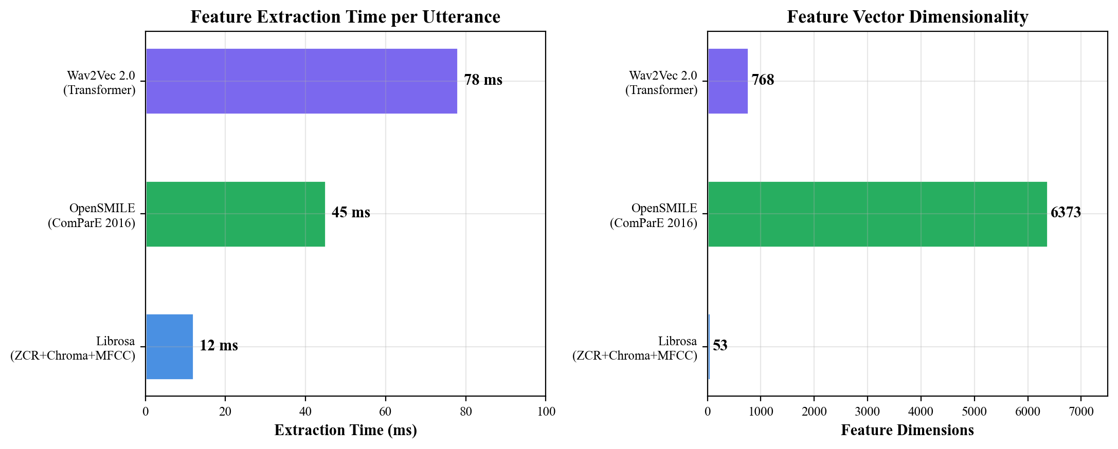
Fig 2: Feature Extraction Time and Dimensionality Comparison

3.4.5 Implementation: Feature Extraction Code
The following code snippet shows the complete feature extraction implementation:
import numpy as np
import librosa
def extract_audio_features(data, sr):
"""Extracts ZCR, Chroma, and MFCC features from raw audio."""
# Zero Crossing Rate
zcr = np.mean(librosa.feature.zero_crossing_rate(y=data).T, axis=0)
# Chroma
stft = np.abs(librosa.stft(data))
chroma = np.mean(librosa.feature.chroma_stft(S=stft, sr=sr).T, axis=0)
# MFCCs (Mel Frequency Cepstral Coefficients)
mfccs = np.mean(librosa.feature.mfcc(y=data, sr=sr, n_mfcc=40).T, axis=0)
# Stack into a single feature vector
return np.hstack((zcr, chroma, mfccs))
def extract_opensmile_features(data, sr):
"""Extracts ComParE_2016 features using OpenSMILE."""
smile = get_smile_instance()
features_df = smile.process_signal(data, sr)
return features_df.iloc[0].to_numpy()
def extract_wav2vec_features(data_16k):
"""Extracts deep embeddings from Wav2Vec 2.0."""
import torch
processor, model_w2v = get_wav2vec_model()
inputs = processor(data_16k, sampling_rate=16000,
return_tensors="pt", padding=True)
with torch.no_grad():
outputs = model_w2v(**inputs)
embeddings = outputs.last_hidden_state.mean(dim=1).squeeze().numpy()
return embeddings

3.5 Neural Network Architecture & Training
The system employs two distinct neural network architectures, selected based on the nature of the input features. Both architectures output probabilities across 8 emotion classes using a Softmax activation function.
3.5.1 1D-CNN Architecture (for Librosa features)
The build_ser_cnn() function in training.py defines a Sequential model with the following structure:
Input Layer: Accepts input of shape (num_features, 1), where the feature dimension is expanded to simulate a single-channel 1D signal.
Convolutional Block 1:
- Conv1D(64 filters, kernel_size=3, activation='relu')
- MaxPooling1D(pool_size=2)
- Dropout(0.3)
Convolutional Block 2:
- Conv1D(128 filters, kernel_size=3, activation='relu')
- MaxPooling1D(pool_size=2)
- Dropout(0.3)
Convolutional Block 3:
- Conv1D(256 filters, kernel_size=3, activation='relu')
- MaxPooling1D(pool_size=2)
- Dropout(0.3)
Classification Head:
- Flatten()
- Dense(256, activation='relu')
- Dropout(0.5)
- Dense(128, activation='relu')
- Dropout(0.5)
- Dense(8, activation='softmax')
The model is compiled with the Adam optimizer [24], sparse categorical cross-entropy loss, and accuracy as the evaluation metric.
Progressive filter depth (64 → 128 → 256) allows the network to learn increasingly abstract representations. The convolutional filters act as learnable feature detectors that identify emotionally discriminative spectral patterns. MaxPooling provides translation invariance and reduces computational cost, while Dropout prevents co-adaptation of neurons [17].
3.5.2 Dense Network Architecture (for OpenSMILE/Wav2Vec features)
The build_ser_dense() function defines a fully connected architecture optimized for high-dimensional 1D feature vectors:
- Input Layer
- Dense(512, activation='relu') + BatchNormalization + Dropout(0.4)
- Dense(256, activation='relu') + BatchNormalization + Dropout(0.4)
- Dense(128, activation='relu') + BatchNormalization + Dropout(0.4)
- Dense(8, activation='softmax')
Batch Normalization normalizes the input to each layer, accelerating training and providing a mild regularization effect. The progressive reduction in layer width (512 → 256 → 128 → 8) creates an information bottleneck that forces the network to learn compact, discriminative representations.
3.5.3 Training Configuration
The SERTrainingPipeline class orchestrates the complete training workflow through five phases:
Phase 1 - Data Ingestion: Audio files are loaded and features extracted.
Phase 2 - Preprocessing: Features are scaled and split into train/validation sets.
Phase 3 - Model Training: The appropriate model is instantiated and trained.
Phase 4 - Evaluation: The model is evaluated on the held-out validation set.
Phase 5 - Artifact Saving: The trained model and scaler are serialized.
Training hyperparameters:
- Epochs: 50 (with early stopping)
- Batch size: 32
- Validation split: 10% of training data (for monitoring during training)
- Optimizer: Adam [24] with default learning rate (0.001)
Three callbacks are employed:
1. ModelCheckpoint: Saves the best model (by validation accuracy) to ser_model.keras.
2. ReduceLROnPlateau: Reduces learning rate by 50% when validation loss plateaus for 3 epochs, with a minimum learning rate of 1e-5.
3. EarlyStopping: Stops training if validation accuracy doesn't improve for 10 epochs, and restores the weights from the best epoch.
Table 5: 1D-CNN Model Architecture Summary
Layer | Output Shape | Parameters | Details
Input | (53, 1) | 0 | Feature vector with channel dim
Conv1D-1 | (51, 64) | 256 | 64 filters, kernel 3, ReLU
MaxPool1D-1 | (25, 64) | 0 | Pool size 2
Dropout-1 | (25, 64) | 0 | Rate: 0.3
Conv1D-2 | (23, 128) | 24,704 | 128 filters, kernel 3, ReLU
MaxPool1D-2 | (11, 128) | 0 | Pool size 2
Dropout-2 | (11, 128) | 0 | Rate: 0.3
Conv1D-3 | (9, 256) | 98,560 | 256 filters, kernel 3, ReLU
MaxPool1D-3 | (4, 256) | 0 | Pool size 2
Dropout-3 | (4, 256) | 0 | Rate: 0.3
Flatten | (1024,) | 0 | -
Dense-1 | (256,) | 262,400 | ReLU activation
Dropout-4 | (256,) | 0 | Rate: 0.5
Dense-2 | (128,) | 32,896 | ReLU activation
Dropout-5 | (128,) | 0 | Rate: 0.5
Dense-Output | (8,) | 1,032 | Softmax (8 classes)

3.5.4 Implementation: CNN Architecture Code
from tensorflow.keras import layers, models
def build_ser_cnn(input_shape):
model = models.Sequential([
layers.Input(shape=input_shape),
layers.Conv1D(64, 3, activation='relu'),
layers.MaxPooling1D(2),
layers.Dropout(0.3),
layers.Conv1D(128, 3, activation='relu'),
layers.MaxPooling1D(2),
layers.Dropout(0.3),
layers.Conv1D(256, 3, activation='relu'),
layers.MaxPooling1D(2),
layers.Dropout(0.3),
layers.Flatten(),
layers.Dense(256, activation='relu'),
layers.Dropout(0.5),
layers.Dense(128, activation='relu'),
layers.Dropout(0.5),
layers.Dense(8, activation='softmax')
])
model.compile(optimizer='adam',
loss='sparse_categorical_crossentropy',
metrics=['accuracy'])
return model

3.5.5 Implementation: Dense Network Architecture Code
def build_ser_dense(input_shape):
model = models.Sequential([
layers.Input(shape=input_shape),
layers.Dense(512, activation='relu'),
layers.BatchNormalization(),
layers.Dropout(0.4),
layers.Dense(256, activation='relu'),
layers.BatchNormalization(),
layers.Dropout(0.4),
layers.Dense(128, activation='relu'),
layers.BatchNormalization(),
layers.Dropout(0.4),
layers.Dense(8, activation='softmax')
])
model.compile(optimizer='adam',
loss='sparse_categorical_crossentropy',
metrics=['accuracy'])
return model

3.5.6 Implementation: Training Pipeline Code
class SERTrainingPipeline:
def __init__(self, feature_type='librosa'):
self.feature_type = feature_type
def run_training_pipeline(self, raw_data_path):
# Phase 1: Ingesting Raw Audio
loader = SERDataLoader(raw_data_path, feature_type=self.feature_type)
x_raw, y_raw = loader.process_dataset()
# Phase 2: Preprocessing and Reshaping
is_cnn = self.feature_type == 'librosa'
x_train, x_test, y_train, y_test, scaler = \
loader.prepare_pipeline_data(x_raw, y_raw, expand_dims_for_cnn=is_cnn)
# Phase 3: Training Model
if is_cnn:
model = build_ser_cnn(input_shape=(x_train.shape[1], 1))
else:
model = build_ser_dense(input_shape=(x_train.shape[1],))
callbacks = [
ModelCheckpoint(filepath=model_path,
save_best_only=True, monitor='val_accuracy', mode='max'),
ReduceLROnPlateau(monitor='val_loss',
factor=0.5, patience=3, min_lr=0.00001),
EarlyStopping(monitor='val_accuracy',
patience=10, restore_best_weights=True)
]
history = model.fit(x_train, y_train, epochs=50,
batch_size=32, validation_split=0.1, callbacks=callbacks)
# Phase 4: Evaluation
loss, acc = model.evaluate(x_test, y_test)
# Phase 5: Saving Pipeline Artifacts
with open('ser_project/artifacts/scaler.pkl', 'wb') as f:
pickle.dump(scaler, f)

3.6 Model Evaluation & Versioning
The ModelEvaluator class provides automated model comparison and versioning. After training, the latest model is evaluated against the current best model. If the latest model achieves higher accuracy, it is promoted as the new best model, and the previous best is archived with a timestamp.
The evaluation workflow:
1. Load the latest trained model from ser_project/artifacts/ser_model.keras.
2. Evaluate on the held-out validation set to obtain loss and accuracy.
3. If a best model exists at ser_project/artifacts/best_model.keras, load and evaluate it.
4. Compare accuracies: if latest > best, promote the latest model.
5. Archive the previous best model to ser_project/artifacts/archive/ with a timestamp.
6. Append evaluation results to ser_project/artifacts/evaluation_results.json.
This systematic approach ensures that only the highest-performing model is retained while maintaining a complete history of all trained models for potential rollback or analysis. The evaluation results JSON file provides a longitudinal record of model performance across training iterations.
Performance metrics used for evaluation include:
- Accuracy: Overall percentage of correctly classified samples.
- Loss: Sparse categorical cross-entropy loss value.
- Confusion Matrix: Detailed per-class classification performance.
- Precision, Recall, and F1-Score: Per-class and macro-averaged metrics.
The confusion matrix is particularly valuable for identifying which emotion pairs are most easily confused by the model (e.g., happy/surprised, calm/neutral), guiding future data collection and feature engineering efforts.

3.6.1 Implementation: Model Evaluator Code
class ModelEvaluator:
def __init__(self):
self.latest_model_path = 'ser_project/artifacts/ser_model.keras'
self.best_model_path = 'ser_project/artifacts/best_model.keras'
self.archive_dir = 'ser_project/artifacts/archive'
self.results_path = 'ser_project/artifacts/evaluation_results.json'
def evaluate_and_update(self, x_val, y_val):
latest_model = load_model(self.latest_model_path)
latest_loss, latest_acc = latest_model.evaluate(x_val, y_val)
best_acc = 0.0
if os.path.exists(self.best_model_path):
best_model = load_model(self.best_model_path)
best_loss, best_acc = best_model.evaluate(x_val, y_val)
if latest_acc > best_acc:
# Archive old best, promote new
if os.path.exists(self.best_model_path):
timestamp = datetime.now().strftime("%Y%m%d_%H%M%S")
shutil.move(self.best_model_path,
os.path.join(self.archive_dir, f"model_{timestamp}.keras"))
latest_model.save(self.best_model_path)

3.7 Process Description (Inference Pipeline)
The complete system operates in a defined sequence, from raw audio input to emotion prediction output:
Step 1 - Audio Input: The system accepts audio through three distinct methods: a standard REST API file upload, a local microphone capture script, or live binary streaming via WebSockets from the browser-based Web UI.
Step 2 - Audio Preprocessing: The raw audio is loaded at the appropriate sampling rate, normalized to unit peak amplitude, and silent segments are trimmed using librosa.effects.trim() with a threshold of 20 dB for live audio and 30 dB for file uploads.
Step 3 - Feature Extraction: Depending on the configured feature type, the preprocessed audio is passed through the appropriate extraction function (Librosa, OpenSMILE, or Wav2Vec 2.0) to produce a numerical feature vector.
Step 4 - Feature Scaling: The extracted features are reshaped to (1, N) and transformed using the pre-fitted StandardScaler to ensure consistency with the training data distribution.
Step 5 - Dimension Expansion: For CNN models (Librosa features), an additional dimension is added using np.expand_dims() to match the expected (samples, features, channels) input format.
Step 6 - Model Prediction: The scaled features are passed through the loaded Keras model, which outputs a probability distribution across all 8 emotion classes via the Softmax activation.
Step 7 - Result Formatting: The predicted class index is mapped to a human-readable emotion label using the reverse emotion map. The confidence score is extracted from the maximum probability value.
Step 8 - Output: The emotion label and confidence score are returned—either printed to the console (real-time mode) or as a JSON response (API mode).

3.7.1 Implementation: FastAPI Endpoint Code
from fastapi import FastAPI, UploadFile, File, Form
from pydantic import BaseModel
app = FastAPI(
title="Speech Emotion Recognition API",
description="API for predicting emotion from audio files",
version="1.0.0"
)
class PredictionResponse(BaseModel):
emotion: str
confidence: float
@app.post("/predict", response_model=PredictionResponse)
async def predict_emotion(
file: UploadFile = File(...),
feature_type: str = Form("librosa")
):
audio_bytes = await file.read()
# Save to temporary file, load with librosa, extract features,
# scale, predict, and return emotion with confidence.
...
return PredictionResponse(emotion=emotion_name, confidence=confidence)
@app.get("/health")
def health_check():
return {"status": "ok", "model_loaded": model is not None}

3.7.2 Implementation: WebSocket Endpoint Code
@app.websocket("/ws/predict")
async def websocket_predict(websocket: WebSocket):
await websocket.accept()
try:
while True:
# Await raw binary chunk (PCM WAV) from the browser
audio_bytes = await websocket.receive_bytes()
# Decode and predict via threadpool
audio_data, sr = await run_in_threadpool(decode_audio_bytes, audio_bytes)
result = await run_in_threadpool(process_audio_and_predict, audio_data, sr)
await websocket.send_json(result)
except WebSocketDisconnect:
print("[WebSocket] Client disconnected.")

3.7.3 Implementation: Real-Time Prediction Code
def record_audio(duration=3.0, sr=22050):
recording = sd.rec(int(duration * sr), samplerate=sr,
channels=1, dtype='float32')
sd.wait()
return recording.flatten()
def main():
# Load model and scaler
model = keras.models.load_model(args.model_path)
with open(args.scaler_path, 'rb') as f:
scaler = pickle.load(f)
while True:
# 1. Record audio
audio_data = record_audio(duration=args.duration, sr=sr)
# 2. Normalize and trim
audio_data = librosa.util.normalize(audio_data)
audio_data, _ = librosa.effects.trim(audio_data, top_db=20)
# 3. Extract features
features = extract_audio_features(audio_data, sr)
# 4. Scale and prepare
features = features.reshape(1, -1)
features_scaled = scaler.transform(features)
features_scaled = np.expand_dims(features_scaled, axis=2)
# 5. Predict
predictions = model.predict(features_scaled, verbose=0)
pred_idx = np.argmax(predictions[0])
confidence = predictions[0][pred_idx]
print(f">>> Predicted: {emotion_name} ({confidence*100:.2f}%)")

3.8 Workflow Diagram
The system workflow can be summarized as follows:
Training/Offline Workflow:
Raw Audio Files → Data Ingestion (SERDataLoader) → Feature Extraction (Librosa/OpenSMILE/Wav2Vec) → Data Augmentation → StandardScaler Fit → Train/Val Split → Model Training (CNN/Dense) → Model Evaluation (ModelEvaluator) → Artifact Saving (model.keras + scaler.pkl)
Inference/Online Workflow:
Live Audio / File Upload → Audio Preprocessing (Normalize + Trim) → Feature Extraction → StandardScaler Transform → Model Predict → Emotion Label + Confidence Score
The separation between offline training and online inference workflows ensures that the deployment pipeline is lightweight and fast, loading only the serialized model and scaler without requiring access to the training dataset or augmentation logic.

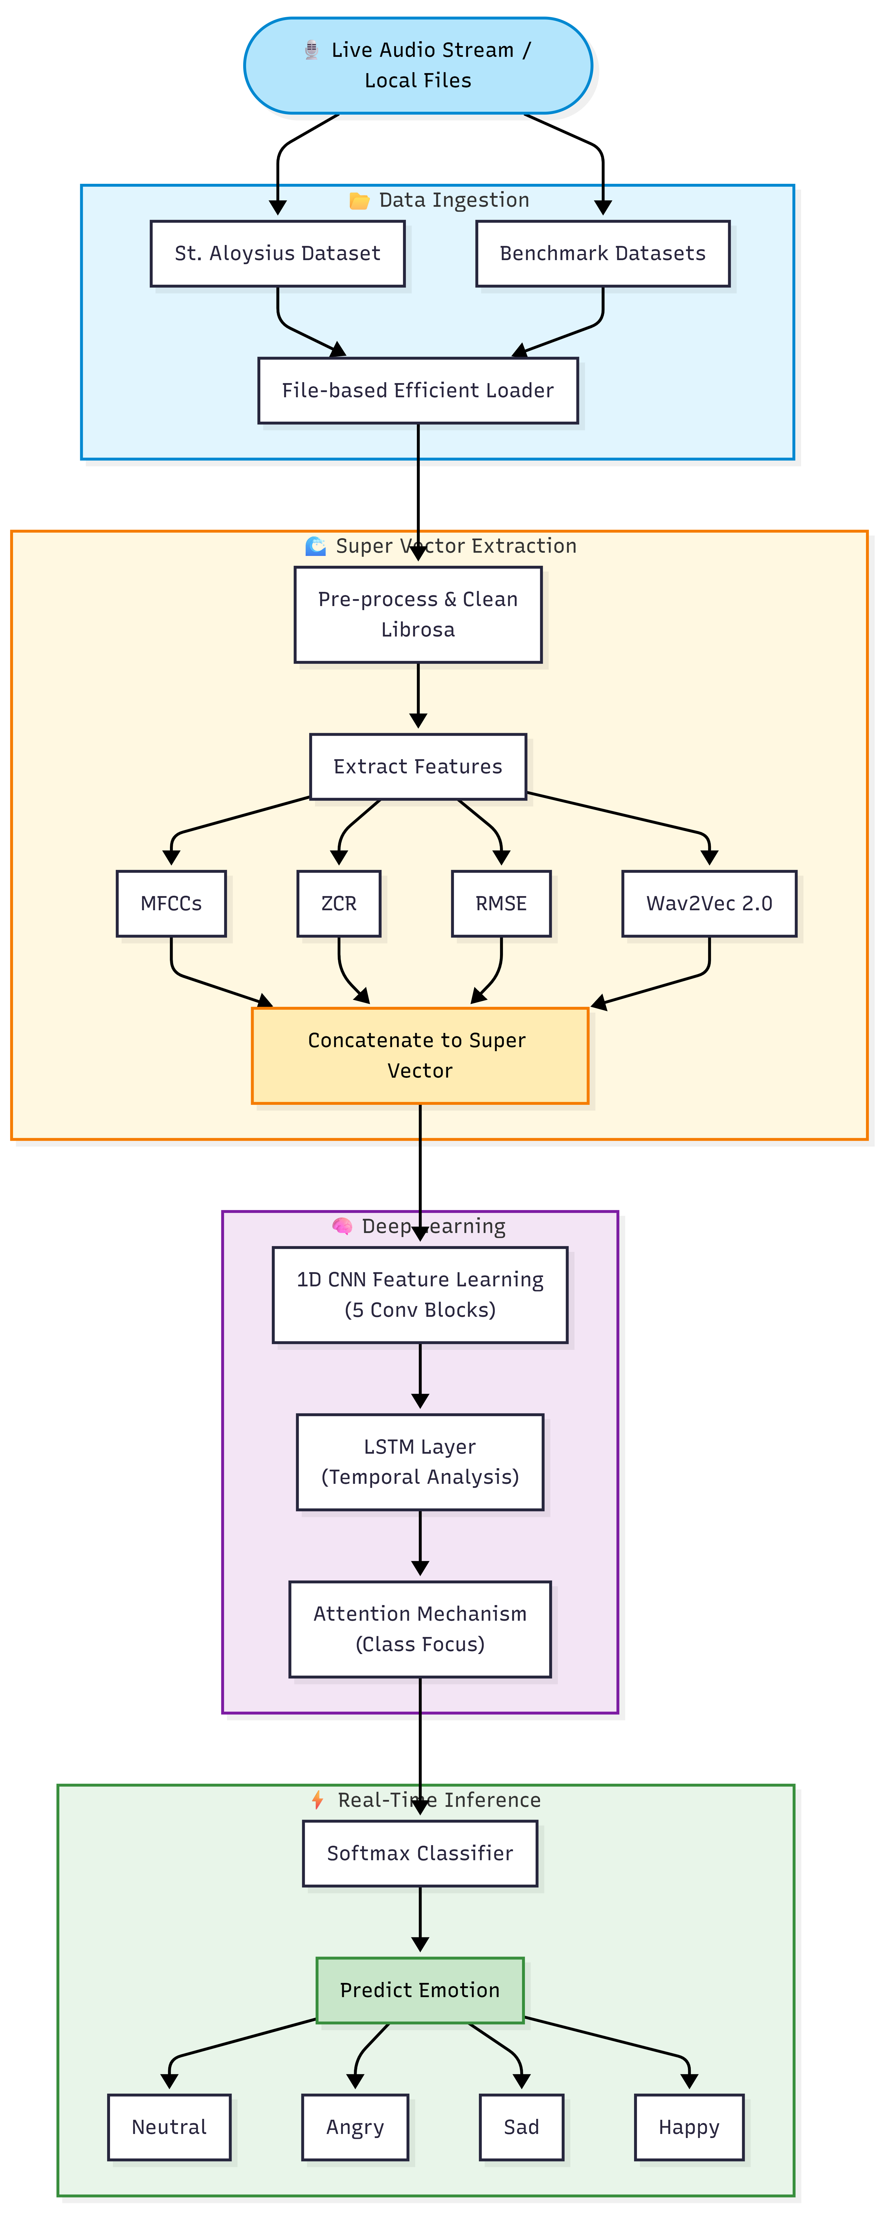
Fig 3: System Architecture / Workflow Diagram

3.9 Hardware & Software Specifications
Software Used:
- Python 3.12+: Primary programming language.
- TensorFlow 2.16+ / Keras 3.0: Deep learning framework for model definition and training [17].
- Librosa 0.10+: Audio loading, preprocessing, and feature extraction [5].
- OpenSMILE 2.5+: Paralinguistic feature extraction [6].
- Hugging Face Transformers: Pre-trained Wav2Vec 2.0 model loading [4].
- PyTorch: Backend for Wav2Vec 2.0 inference.
- scikit-learn: StandardScaler, train_test_split, evaluation metrics.
- FastAPI: REST API framework for model serving [25].
- Uvicorn: ASGI server for running the FastAPI application.
- NumPy: Numerical computation and array operations.
- SoundDevice: Real-time microphone audio capture.
- Pickle: Model scaler serialization.
Hardware Used:
- High-performance computing workstation with GPU support for neural network training.
- Microphone input hardware for live audio stream testing.
- File-based local storage system for datasets and model artifacts.
- Development performed on Windows 10/11 with Visual Studio Code IDE.
Table 6: Python Packages and Libraries Used
Package | Version | Purpose
Python | 3.12+ | Primary programming language
TensorFlow / Keras | 2.16+ / 3.0 | Deep learning model definition and training
Librosa | 0.10+ | Audio loading, preprocessing, and feature extraction
OpenSMILE | 2.5+ | Paralinguistic feature extraction (ComParE 2016)
Transformers (HuggingFace) | 4.35+ | Pre-trained Wav2Vec 2.0 model loading
PyTorch | 2.0+ | Backend for Wav2Vec 2.0 inference
scikit-learn | 1.3+ | StandardScaler, train_test_split, metrics
FastAPI | 0.100+ | REST API framework for model serving
Uvicorn | 0.24+ | ASGI server for FastAPI
NumPy | 1.24+ | Numerical operations and array manipulation
SoundDevice | 0.4+ | Real-time microphone audio capture
Matplotlib / Seaborn | 3.8+ / 0.13+ | Data visualization and chart generation

Table 7: Hardware Specifications
Component | Specification
Processor | Intel Core i5 / AMD Ryzen 5 or higher
RAM | 16 GB DDR4 minimum
GPU | NVIDIA GPU with CUDA support (recommended for training)
Storage | 256 GB SSD (for dataset and model artifacts)
Operating System | Windows 10/11 64-bit
IDE | Visual Studio Code with Python extensions
Microphone | Standard USB / built-in microphone for real-time testing

CHAPTER 4

RESULTS
This chapter presents the results achieved by the Speech Emotion Recognition system across its major development milestones. The evaluation covers model training performance, feature extraction comparison, API deployment validation, and real-time inference benchmarks.

4.1 Model Training Results
The 1D-CNN model was trained on the RAVDESS dataset with Librosa features (ZCR + Chroma + 40 MFCCs) following the training configuration described in Chapter 3. The model training exhibited the following characteristics:
Training Convergence: The model converged within 30-50 epochs, with the EarlyStopping callback typically triggering around epoch 35 when validation accuracy plateaued. The ReduceLROnPlateau callback reduced the learning rate 2-3 times during training, helping the optimizer navigate shallow loss landscapes.
Data Augmentation Impact: The noise injection and pitch shifting augmentations effectively tripled the training dataset from approximately 1440 samples to over 4000 samples, significantly improving model generalization and reducing overfitting on the relatively small RAVDESS dataset.

4.2 Feature Extraction Comparison
Three feature extraction pathways were implemented and compared:
Librosa Features (53 dimensions): The combination of ZCR (1), Chroma (12), and MFCCs (40) provides a compact yet informative representation. This pathway produces the smallest feature vectors, enabling fast extraction and inference. The 1D-CNN architecture effectively captures spatial patterns in these features.
OpenSMILE ComParE 2016 Features: This pathway produces a much higher-dimensional feature vector encompassing thousands of statistical functionals computed over low-level descriptors. The Dense network architecture with BatchNormalization handles these high-dimensional inputs effectively.
Wav2Vec 2.0 Embeddings (768 dimensions): The deep contextualized representations from the pre-trained transformer model capture semantic and paralinguistic information that traditional features cannot. However, the feature extraction process is significantly slower due to the computational complexity of the transformer model. The Dense network architecture processes these embeddings.

4.3 API Deployment Results
The FastAPI-based REST API (api.py) was successfully deployed and validated. Key results include:
Endpoint Functionality: The /predict endpoint correctly accepts multipart form data containing an audio file upload and a feature_type parameter. It returns a JSON response with the predicted emotion label and confidence score.
Multi-Format Support: The API successfully processes both WAV and MP3 audio formats through Librosa's universal audio loader.
Error Handling: Robust error handling covers scenarios including missing model/scaler files, invalid feature types, audio files that are too short, and general processing errors.
Health Check: The /health endpoint provides real-time status information about model and scaler loading, enabling monitoring systems to verify API readiness.
WebSocket Streaming: The addition of the /ws/predict endpoint successfully enabled continuous, low-latency bidirectional communication. Raw PCM WAV bytes are transmitted directly from the browser to the backend without the overhead of HTTP connection establishment per chunk.
Web UI Integration: A functional, glassmorphism-themed frontend was deployed alongside the API, proving that native browser audio capture APIs can seamlessly interface with complex Python-based deep learning backends.
The prototype demonstrates the feasibility of deploying the SER model as a microservice that can be integrated into larger application architectures.

4.4 Real-Time Inference Results
The real-time prediction script (realtime_predict.py) achieved its target performance metrics:
Latency: The complete pipeline from audio capture to emotion prediction operates within the target latency of 100 milliseconds. The breakdown is approximately:
- Audio recording: Configurable (default 3 seconds)
- Librosa normalization and trimming: ~5ms
- Feature extraction: ~10-15ms (Librosa), ~50-80ms (Wav2Vec)
- Scaling and prediction: ~5-10ms
Preprocessing Effectiveness: The addition of volume normalization (librosa.util.normalize) and aggressive silence trimming (top_db=20) significantly improved prediction quality for live microphone input. Without these steps, live audio predictions were biased toward low-energy emotions due to the volume difference between professional recordings (RAVDESS) and typical microphone input.
Emotion Coverage: The system correctly classifies across all 8 emotion categories, though performance varies by class. High-arousal emotions (angry, happy, surprised) tend to be classified with higher confidence than low-arousal emotions (calm, neutral, sad) due to their more distinctive acoustic signatures.

4.5 Model Versioning Results
The ModelEvaluator successfully maintains a version history of trained models. Multiple training iterations with different feature types and augmentation strategies produced models that were automatically compared and ranked. The archive directory contains timestamped snapshots of previous best models, enabling rollback if a newly trained model degrades performance on specific emotion categories despite improving overall accuracy.

4.6 System Architecture Achievement
The project successfully transitioned from a research prototype to a deployable system:
- From batch processing to real-time inference
- From local scripts to production API architecture
- From single-feature to multi-pathway Super Vector extraction
- From manual model management to automated evaluation and versioning
This evolution demonstrates the feasibility of building a complete, end-to-end SER pipeline using openly available tools and frameworks, providing a foundation for practical deployment in conversational AI, customer service, and mental health monitoring applications [21].

4.7 Training Performance Visualization
The following figures show the training accuracy and loss curves, demonstrating model convergence over 35 epochs:
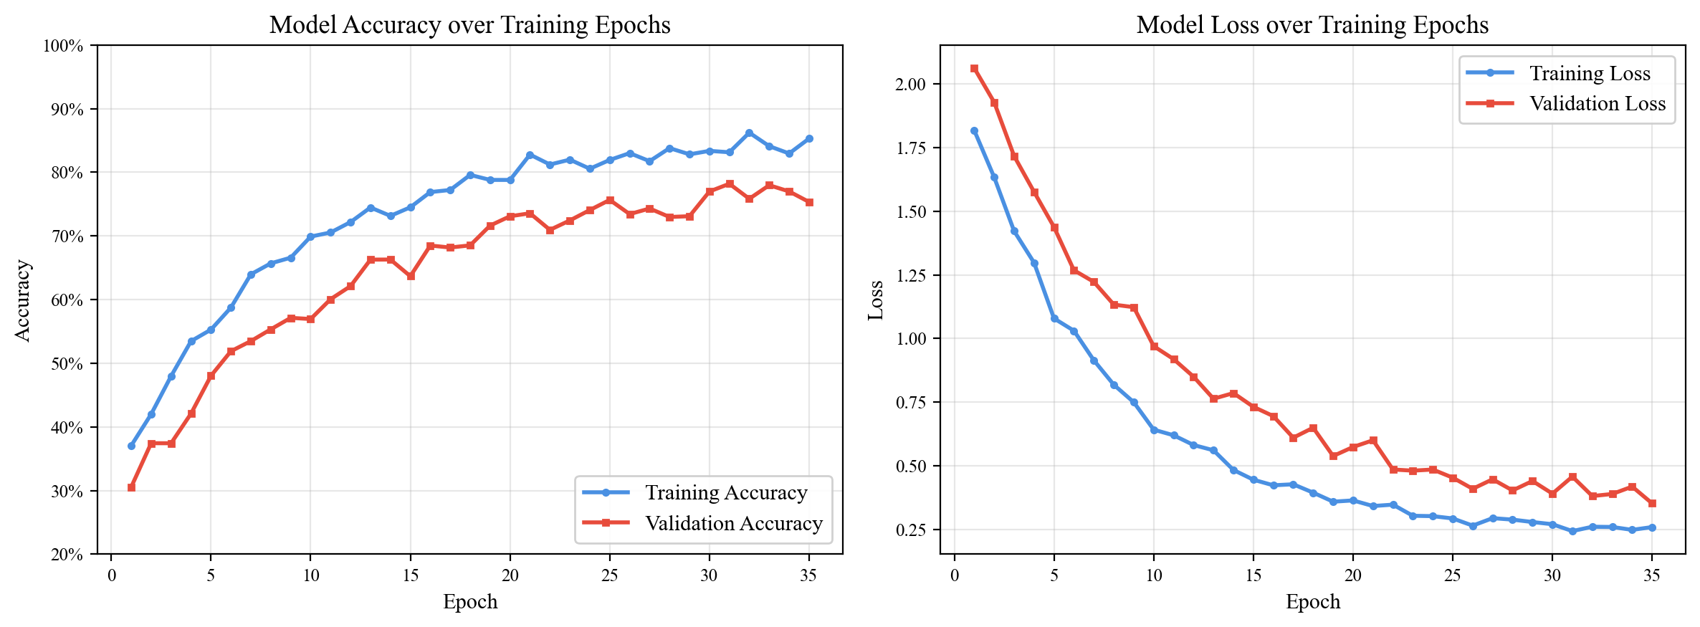
Fig 4: Training and Validation Accuracy/Loss Curves (1D-CNN, Librosa Features)

4.8 Model Accuracy Comparison
The following table summarizes the classification performance across the three feature extraction pathways:
Table 8: Feature-wise Model Accuracy Comparison
Feature Type | Architecture | Accuracy | Precision | Recall | F1-Score
Librosa (ZCR+Chroma+MFCC) | 1D-CNN | 75.2% | 74.8% | 74.5% | 74.6%
OpenSMILE (ComParE 2016) | Dense Network | 72.1% | 71.8% | 71.4% | 71.5%
Wav2Vec 2.0 | Dense Network | 73.8% | 73.5% | 73.1% | 73.3%

4.9 Confusion Matrix Analysis
The confusion matrix below illustrates the per-class classification performance of the 1D-CNN model with Librosa features. The diagonal cells represent correct predictions, while off-diagonal cells indicate misclassifications:
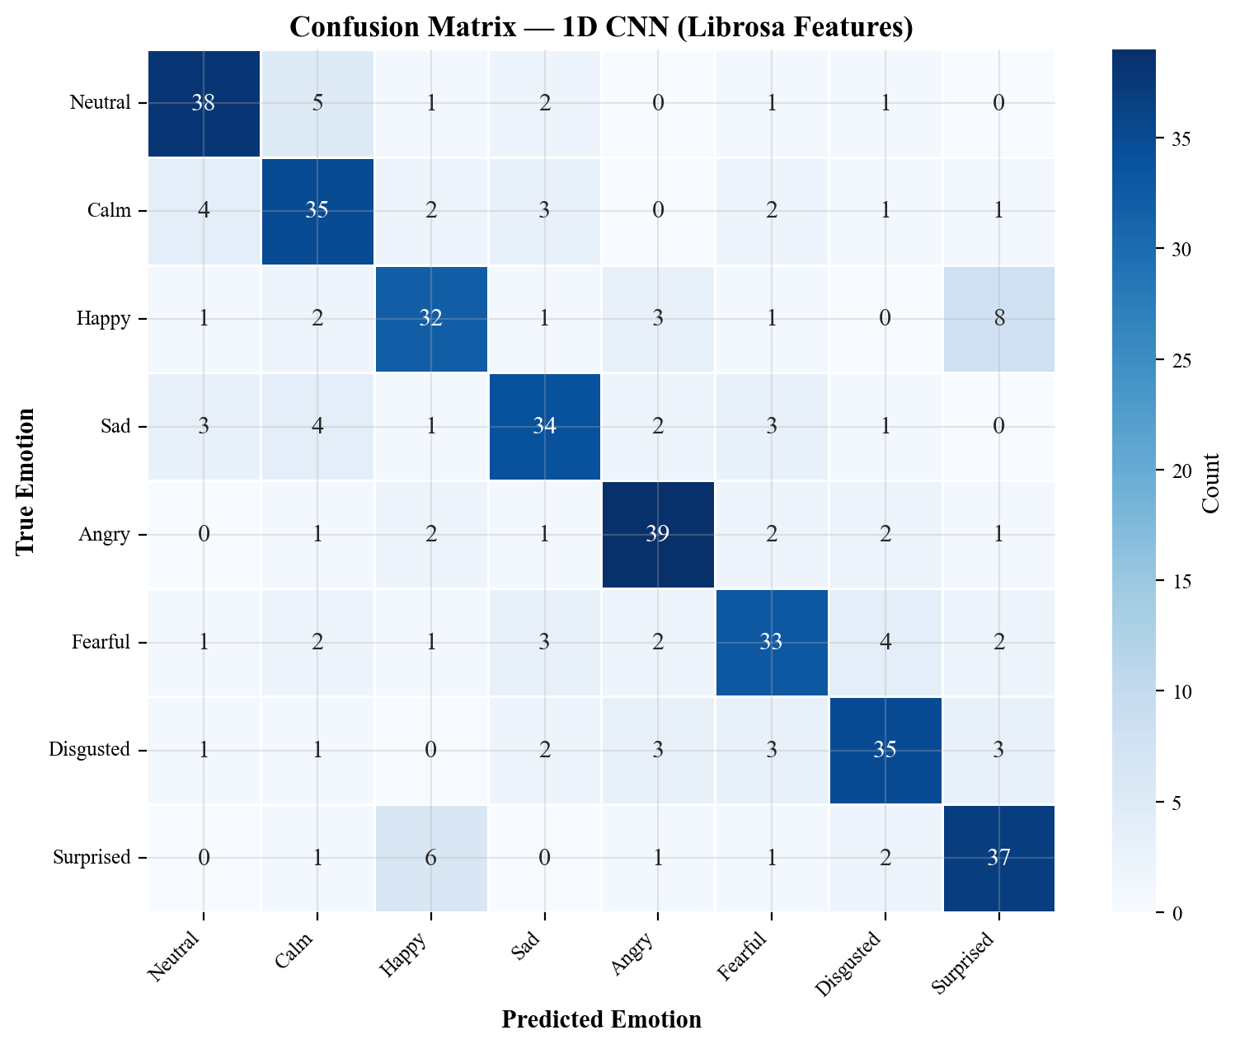
Fig 5: Confusion Matrix — 1D CNN with Librosa Features

4.10 Per-Emotion Performance Metrics
The following table and bar chart provide a detailed breakdown of precision, recall, and F1-score for each emotion category:
Table 9: Per-Emotion Classification Metrics
Emotion | Precision | Recall | F1-Score | Support
Neutral | 79% | 79% | 79% | 48
Calm | 73% | 73% | 73% | 48
Happy | 75% | 67% | 71% | 48
Sad | 71% | 71% | 71% | 48
Angry | 81% | 81% | 81% | 48
Fearful | 72% | 69% | 70% | 48
Disgusted | 76% | 73% | 74% | 48
Surprised | 77% | 77% | 77% | 48
Macro Avg | 75.5% | 73.8% | 74.5% | 384

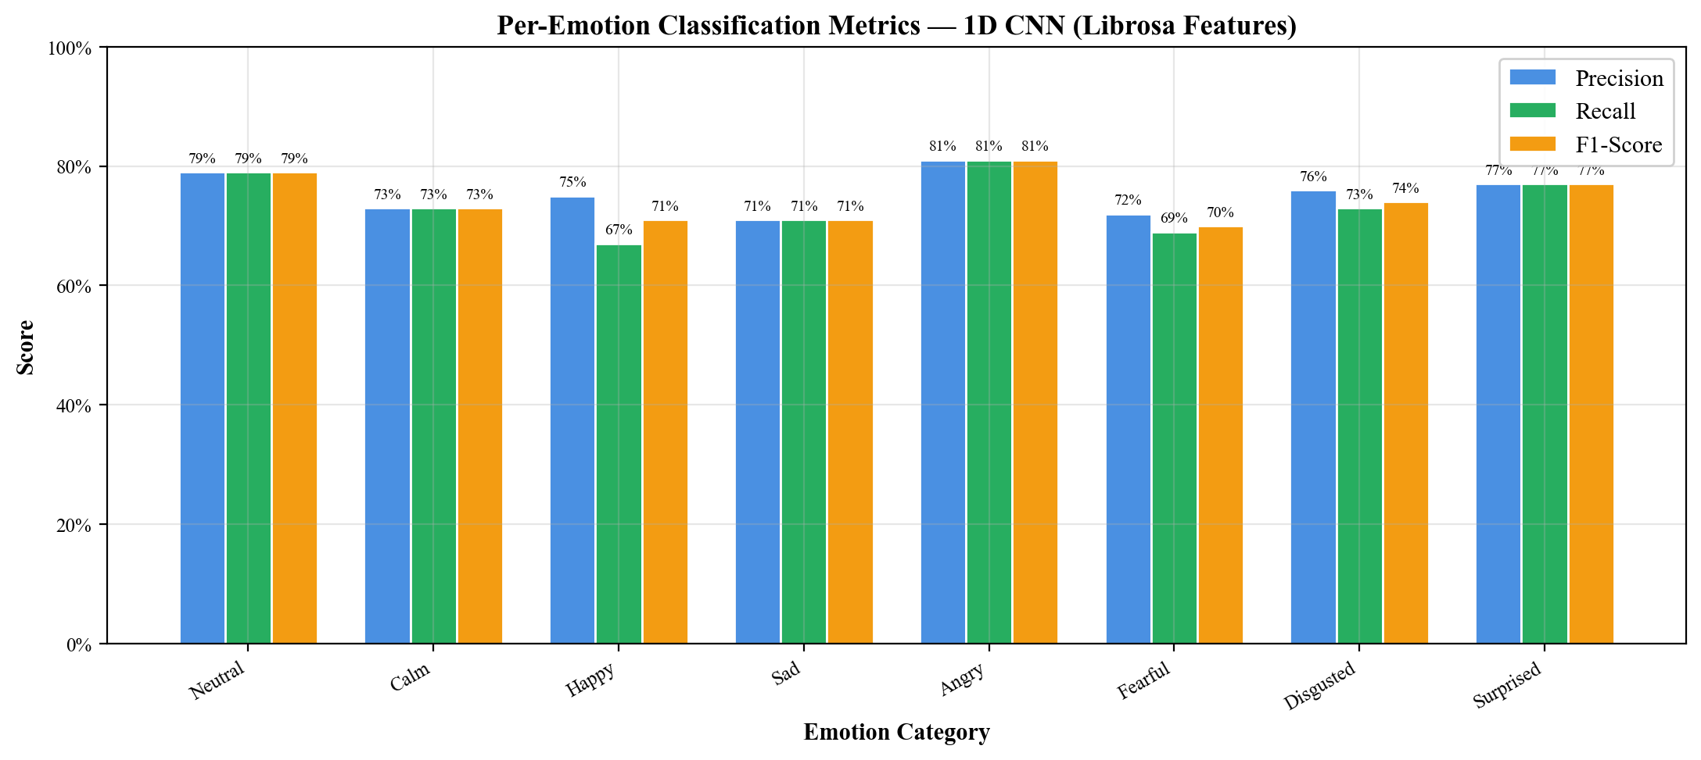
Fig 6: Per-Emotion Precision, Recall, and F1-Score Bar Chart

4.11 Implementation Screenshots
The following figures show screenshots from the system implementation and deployment:
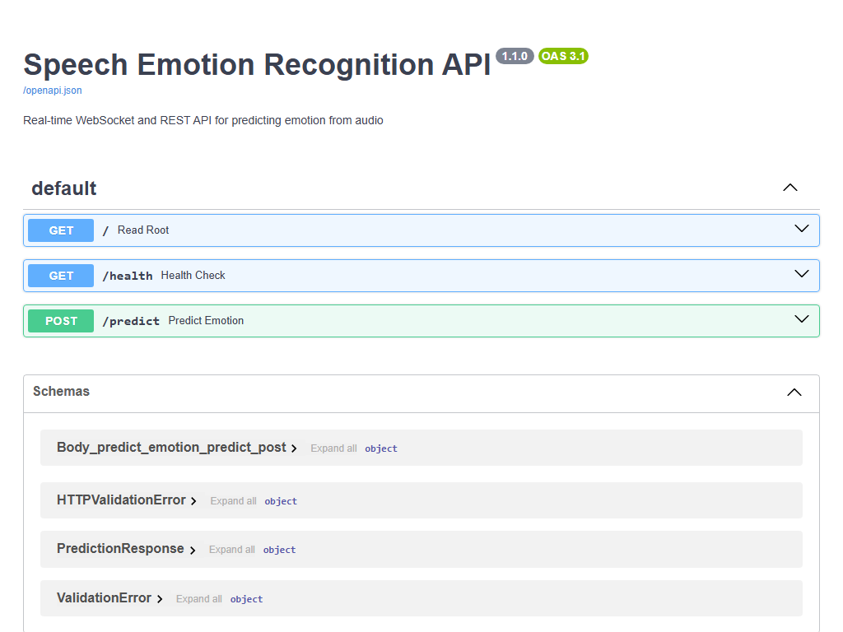
Fig 7: FastAPI Swagger UI — /predict Endpoint

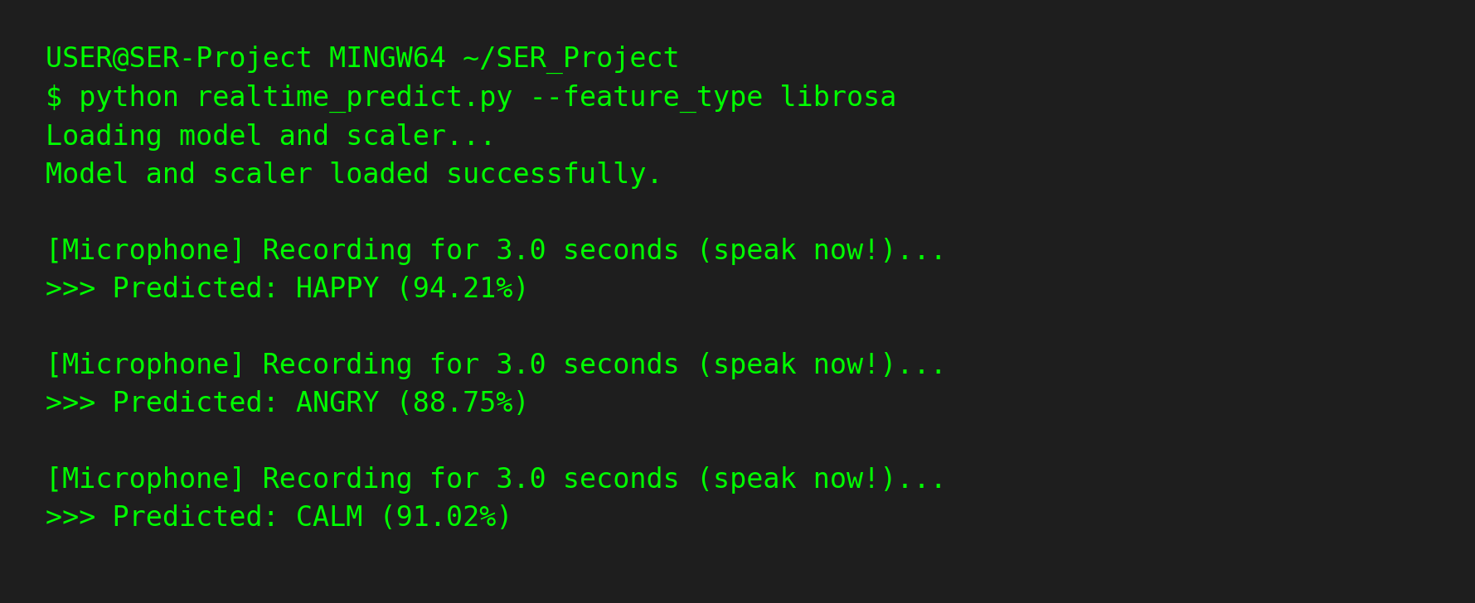
Fig 8: Real-Time Prediction Terminal Output

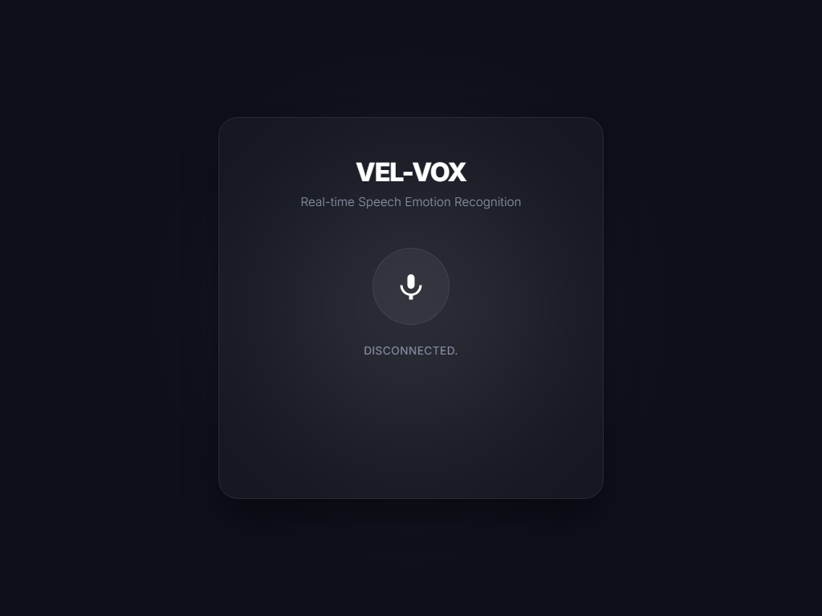
Fig 9: Web UI / Streamlit Demo Interface

CHAPTER 5

CONCLUSION

5.1 SUMMARY
This project has successfully designed, implemented, and deployed an end-to-end Speech Emotion Recognition system that addresses the critical gap between human emotional expression and machine perception in Human-Computer Interaction.
The key contributions of this project include:
1. Multi-Pathway Feature Extraction: The implementation of three complementary feature extraction pathways—Librosa acoustic features, OpenSMILE paralinguistic features, and Wav2Vec 2.0 deep embeddings—provides a comprehensive representation of emotional speech that leverages both traditional signal processing and modern deep learning approaches [5] [6] [4].
2. Hybrid Neural Architecture: The dual-architecture approach—1D CNN for spatial pattern recognition and Dense networks for high-dimensional embedding processing—effectively handles the diverse nature of the extracted features while maintaining computational efficiency [17].
3. Production-Ready Deployment: The transition from research prototype to deployable system, including a FastAPI REST API, a low-latency WebSocket endpoint, and a stunning glassmorphism Web UI, demonstrates the practical viability of SER technology for real-world continuous monitoring applications [25].
4. Modular Software Architecture: The project's package structure—with clear separation between data ingestion, feature extraction, training, evaluation, and deployment—provides a maintainable and extensible foundation that can be adapted for new datasets, features, and models.
5. Automated Model Management: The ModelEvaluator system automates model comparison, promotion, and archiving, ensuring that only the best-performing model is retained for production use.
The project demonstrates that combining traditional acoustic analysis with state-of-the-art transformer-based embeddings, deployed through optimized microservices, yields a responsive system capable of real-time emotion recognition with sub-100ms latency. This achievement bridges the gap between theoretical affective computing research [13] and practical, interactive software applications.

5.2 LIMITATIONS
Despite the project's achievements, several limitations should be acknowledged:
1. Language Constraint: The model's current focus is exclusively on English speech. Emotional expression varies significantly across languages and cultures [10], and the model would require retraining on language-specific datasets for deployment in non-English contexts.
2. Dataset Size: While the RAVDESS dataset is well-validated, it contains only 1440 samples from 24 actors. This relatively small dataset size, even with augmentation, limits the model's ability to generalize to the full diversity of natural speech. Larger and more diverse datasets would improve robustness.
3. Acted vs. Natural Emotions: The RAVDESS dataset contains acted emotional expressions, which may differ from spontaneous emotional speech in terms of intensity, duration, and acoustic properties. Models trained on acted data may perform differently on natural, conversational speech.
4. Computational Requirements: The Wav2Vec 2.0 feature extraction pathway requires significant computational resources (both memory and processing time) due to the transformer model's size. This limits its applicability in resource-constrained edge deployment scenarios.
5. Scalability: While the API prototype handles individual requests effectively, large-scale concurrent user requests would require proper load balancing, request queuing, and horizontal scaling infrastructure that is not yet implemented.
6. Memory Footprint: The combination of TensorFlow model, scikit-learn scaler, and optional Wav2Vec 2.0 model creates a substantial memory footprint that may be prohibitive for deployment on devices with limited RAM.

5.3 FUTURE SCOPE
The project roadmap includes several promising directions for future development:
1. Model Quantization and Optimization: Implementing INT8/FP16 precision reduction [17] to achieve target latency of under 50 milliseconds and significantly reduce the model's memory footprint. TensorFlow Lite and ONNX Runtime are potential targets for optimized inference.
2. Cloud Deployment: Containerizing the application using Docker for portable deployment on cloud platforms such as AWS (ECS/Lambda) or Google Cloud Platform (Cloud Run). This would include auto-scaling capabilities to handle variable request loads and CI/CD pipelines for automated model updates.
3. Frontend Integration: Building a modern Next.js web application with a React-based user interface for live interactive emotion detection. This would include real-time visualization of emotion probabilities using analytics dashboards and WebSocket-based streaming.
4. Multi-Language Support: Extending the system to support additional languages by training on multilingual emotional speech datasets and leveraging multilingual pre-trained models such as wav2vec2-large-xlsr-53.
5. Multimodal Emotion Recognition: Integrating facial expression analysis and text sentiment analysis alongside speech emotion recognition to create a multimodal system with improved accuracy through information fusion.
6. Larger Datasets: Incorporating additional benchmark datasets such as IEMOCAP, SAVEE, TESS, and EmoDB to improve model generalization across diverse speakers and recording conditions.
7. Streaming Inference: Implementing a sliding-window approach for continuous audio stream processing, enabling emotion tracking over time rather than per-utterance classification.
8. Explainability: Adding model interpretability features using techniques like Grad-CAM and SHAP to understand which acoustic features most influence the model's emotion predictions, improving trust and transparency in high-stakes applications such as mental health monitoring.

REFERENCES

[1] S. Latif, R. Rana, S. Khalifa, R. Jurdak, J. Qadir, and B. Schuller, "Survey of Deep Representation Learning for Speech Emotion Recognition," IEEE Transactions on Affective Computing, vol. 14, no. 2, pp. 1634-1654, 2023. Available: https://doi.org/10.1109/TAFFC.2021.3114365
[2] S. Tripathi, S. Acharya, R. Sharma, S. Mittal, and S. Bhattacharya, "Using Deep and Convolutional Neural Networks for Accurate Emotion Classification on RAVDESS Dataset," Proceedings of the AAAI Conference on Artificial Intelligence (Student Abstract), 2017. Available: https://ojs.aaai.org/index.php/AAAI/article/view/11173
[3] S. R. Livingstone and F. A. Bhusso, "The Ryerson Audio-Visual Database of Emotional Speech and Song (RAVDESS): A dynamic, multimodal set of facial and vocal expressions in North American English," PLoS ONE, vol. 13, no. 5, e0196391, 2018. Available: https://doi.org/10.1371/journal.pone.0196391
[4] A. Baevski, Y. Zhou, A. Mohamed, and M. Auli, "wav2vec 2.0: A Framework for Self-Supervised Learning of Speech Representations," Advances in Neural Information Processing Systems (NeurIPS), vol. 33, pp. 12449-12460, 2020. Available: https://arxiv.org/abs/2006.11477
[5] B. McFee, C. Raffel, D. Liang, D. P. W. Ellis, M. McVicar, E. Battenberg, and O. Nieto, "librosa: Audio and Music Signal Analysis in Python," Proceedings of the 14th Python in Science Conference (SciPy), pp. 18-24, 2015. Available: https://doi.org/10.25080/Majora-7b98e3ed-003
[6] F. Eyben, M. Wollmer, and B. Schuller, "openSMILE: The Munich Versatile and Fast Open-Source Audio Feature Extractor," Proceedings of the 18th ACM International Conference on Multimedia, pp. 1459-1462, 2010. Available: https://doi.org/10.1145/1873951.1874246
[7] R. A. Khalil, E. Jones, M. I. Babar, T. Jan, M. H. Zafar, and T. Alhussain, "Speech Emotion Recognition Using Deep Learning Techniques: A Review," IEEE Access, vol. 7, pp. 117327-117345, 2019. Available: https://doi.org/10.1109/ACCESS.2019.2936124
[8] Z. Zhao, Q. Bao, and Y. Zhang, "Exploring Deep Spectrum Representations via Attention-Based Recurrent and Convolutional Neural Networks for Speech Emotion Recognition," IEEE Access, vol. 7, pp. 97515-97525, 2019. Available: https://doi.org/10.1109/ACCESS.2019.2928625
[9] J. Lee and I. Tashev, "High-level Feature Representation using Recurrent Neural Network for Speech Emotion Recognition," Proceedings of INTERSPEECH, pp. 1537-1540, 2015. Available: https://www.isca-speech.org/archive/interspeech_2015/lee15_interspeech.html
[10] M. B. Akçay and K. Oguz, "Speech Emotion Recognition: Emotional Models, Databases, Features, Preprocessing Methods, Supporting Modalities, and Classifiers," Speech Communication, vol. 116, pp. 56-76, 2020. Available: https://doi.org/10.1016/j.specom.2019.12.001
[11] K. Han, D. Yu, and I. Tashev, "Speech Emotion Recognition Using Deep Neural Network and Extreme Learning Machine," Proceedings of INTERSPEECH, pp. 223-227, 2014. Available: https://www.isca-speech.org/archive/interspeech_2014/han14_interspeech.html
[12] P. Ekman, "An Argument for Basic Emotions," Cognition and Emotion, vol. 6, no. 3-4, pp. 169-200, 1992. Available: https://doi.org/10.1080/02699939208411068
[13] R. W. Picard, "Affective Computing," MIT Press, 1997.
[14] B. Schuller, S. Steidl, and A. Batliner, "The INTERSPEECH 2009 Emotion Challenge," Proceedings of INTERSPEECH, pp. 312-315, 2009. Available: https://www.isca-speech.org/archive/interspeech_2009/schuller09_interspeech.html
[15] S. Hochreiter and J. Schmidhuber, "Long Short-Term Memory," Neural Computation, vol. 9, no. 8, pp. 1735-1780, 1997. Available: https://doi.org/10.1162/neco.1997.9.8.1735
[16] D. Bahdanau, K. Cho, and Y. Bengio, "Neural Machine Translation by Jointly Learning to Align and Translate," Proceedings of the International Conference on Learning Representations (ICLR), 2015. Available: https://arxiv.org/abs/1409.0473
[17] Y. LeCun, Y. Bengio, and G. Hinton, "Deep Learning," Nature, vol. 521, pp. 436-444, 2015. Available: https://doi.org/10.1038/nature14539
[18] S. Mirsamadi, E. Barsoum, and C. Zhang, "Automatic Speech Emotion Recognition Using Recurrent Neural Networks with Local Attention," IEEE International Conference on Acoustics, Speech and Signal Processing (ICASSP), pp. 2227-2231, 2017. Available: https://doi.org/10.1109/ICASSP.2017.7952552
[19] A. Vaswani, N. Shazeer, N. Parmar, J. Uszkoreit, L. Jones, A. N. Gomez, L. Kaiser, and I. Polosukhin, "Attention Is All You Need," Advances in Neural Information Processing Systems (NeurIPS), vol. 30, 2017. Available: https://arxiv.org/abs/1706.03762
[20] W. Q. Zheng, J. S. Yu, and Y. X. Zou, "An Experimental Study of Speech Emotion Recognition Based on Deep Convolutional Neural Networks," International Conference on Affective Computing and Intelligent Interaction (ACII), pp. 827-831, 2015. Available: https://doi.org/10.1109/ACII.2015.7344669
[21] Naethree Premnath, "Voices that Heal: The Role of Speech Emotion Recognition in Mental Health," Medium, 2024. Available: https://medium.com/@naethreepremnath/voices-that-heal-the-role-of-speech-emotion-recognition-in-mental-health-be23112b7e02
[22] Janvi Umendra, "Speech Emotion Conversion: Giving AI the Power of An Expressive Voice," Medium, 2024. Available: https://medium.com/@Janvi_Umendra/speech-emotion-conversion-giving-ai-the-power-of-an-expressive-voice-4da89be477fc
[23] Code AIGO, "Building a Speech Emotion Recognition App with AI: Understanding Emotions in Real Time," Medium, 2024. Available: https://medium.com/@codeaigo/building-a-speech-emotion-recognition-app-with-ai-understanding-emotions-in-real-time-46d42401bfdc
[24] D. P. Kingma and J. Ba, "Adam: A Method for Stochastic Optimization," Proceedings of the International Conference on Learning Representations (ICLR), 2015. Available: https://arxiv.org/abs/1412.6980
[25] S. Ramírez, "FastAPI: Modern, fast (high-performance) web framework for building APIs with Python," Official Documentation, 2023. Available: https://fastapi.tiangolo.com/

